

Requirement & Design Specification
Kitchenware Shopping Online System (KSOS)
Version: 1.0

HE170483 - Đỗ Ngọc Đức
HE181730 - Trần Thị Tú Anh
HE180860 - Nguyễn Đăng Việt

– Hanoi, January 2025 –

Record of Changes
Version | Date | A*  M, D | In charge | Change Description
V1.0 | 21/1 | A | AnhTTTHE181730 | add system context, system functionalities
V1.0 | 21/1 | A | DucDNHE170483 | add use case diagram
V1.0 | 21/1 | A | VietNDHE180860 | add Functional Requirements for account sign-in.
V1.0 | 22/1 | A | VietNDHE 180860 | add Functional Requirements for account sign-up.
V1.0 | 22/1 | A, M | DucDNHE170483 | update use case diagram, add description for UCD
V1.0 | 24/1 | A | VietNDHE180860 | add Functional Requirements for reset password.
V1.0 | 25/1 | A | DucDNHE170483 | add function requirement for logout
V1.0 | 27/1 | A | DucDNHE170483 | add Functional Requirements for profile
V1.0 | 27/1 | A | VietNDHE180860 | add Functional Requirements for profile (avatar profile)
V1.0 | 7/2 | A | BachCXHE172774 | add Functional Requirements for profile ( add and deleted customer address)
V1.0 | 7.2 | A | BachCXHE172774 | add Functional Requirements for profile ( edit customer address)
V1.0 | 8/2 | M | DucDNHE170483 | update Functional Requirements for profile
V1.0 | 9/2 | A | AnhTTTHE181730 | add Functional Requirement for change password, Home Screen
V1.0 | 9/2 | A | ThangCHHE170988 | add Functional Requirements for view staff account (View staff information).
v1.0 | 9/2 | A | ThangCHHE170988 | add Functional Requirements for view staff accounts (Display all staff accounts).
V2.0 | 25/2 | M | Vietndhe180860 | Update database diagram
V2.0 | 25/2 | A | DucDNHE170483 | Add function requirement for category
V2.0 | 26/2 | A | Vietndhe180860 | Add function requirement for wallet
V2.0 | 27/2 | A | Vietndhe180860 | Add package diagram
V2.0 | 27/2 | M | DucDNHE170483 | Update function requirement for category
V2.0 | 28/2 | M | DucDNHE170483 | Update use case diagram
V2.0 | 28/2 | M | Thangchhe170988 | Add function requirement for brand
V3.0 | 12/3 | M | DucDNHE170483 | Update use case diagram
V2.0 | 1/3 | A | AnhTTTHE181730 | Add Functional Requirement for coupon, create, update staff account.
V2.0 | 20/03 | M | AnhTTTHE181730 | Modified Context, Usecase, Screenflow, Main Flow diagram
v2.0 | 21/03 | A | AnhTTTHE181730 | Add product-details, customer analyst, update order status
v2.0 | 21/3 | A | Vietndhe180860 | Add all order customer - related function
v2.0 | 21/3 | A | Vietndhe180860 | Add package description
v2.0 | 21/3 | M | DucDNHE170483 | Modified function requirement for category
v2.0 | 21/3 | A | DucDNHE170483 | Add function requirement for contact
v3.0 | 25/03 | M | AnhTTTHE181730 | Modified screen flow diagram and screen authorization
*A - Added M - Modified D - Deleted
Contents
Record of Changes 2
I. Overview 7
1. System Context 7
2. User Requirements 7
2.1 Actors 7
2.2 Diagrams 8
2.2.1 UCs for Guest 8
2.2.2 UCs for Common 9
2.2.3 UCs for Customer… 9
2.2.4 UCs for Sale Staff 11
2.2.5 UCs for Delivery Staff 12
2.2.6 UCs for Warehouse Staff 12
2.2.7 UCs for Admin 13
2.3 Descriptions 13
2.4 Main Workflows 16
3. System Functionalities 17
3.1 Screens Flow 17
3.2 Screen Authorization 18
3.3 Non-UI Functions 19
II. Functional Requirements 21
1. Common Function 21
1.1 Sign-In Screen 21
1.2 Register Screen 22
1.3 Reset Password… 23
1.4 Home Screen 24
1.5 Profile 25
1.6 Logout 27
1.7 Change Password 28
1.8 Address 29
1.9 Notification 30
1.10 Contact 31
2. Customer Function 34
2.1 Cart 34
2.2 Wallet … 35
2.2.1 Wallet Manager 35
2.2.2 Active Wallet 36
2.2.3 Change Passcode Wallet 37
2.2.4 Deposit Into Wallet 38
2.3 Order … 39
2.3.1 Create Order 39
2.3.2 Cancel Order 40
2.3.3 View Order List 41
2.3.4 PayOS Payment 42
2.3.5 Wallet Payment 43
2.3.6 Feedback Order 44
2.3.7 Order Detail 45
3. Sale Staff Function 48
3.1 Category 48
3.1.1 View All Category 48
3.1.2 View Detail Category 49
3.1.3 Edit Category 50
3.1.4 Add Category 51
3.2 Brand 53
3.2.1 View All Brand 53
3.2.2 View Brand Detail 54
3.2.3 Update Brand 55
3.2.4 Add Brand 56
3.3 Banner 58
3.3.1 Manager Banner 58
3.3.2 Add Banner 59
3.3.3 Edit Banner 60
3.4 Coupon 62
3.4.1 View Coupon List 62
3.4.2 Create New Coupon 63
3.4.3 Update Coupon 64
3.5 Product 65
3.5.1 View Product List 65
3.5.2 Create New Product 66
3.5.3 Update Product 67
3.5.4 Product Details 68
3.6 Feedback Manager 69
3.6.1 Show List Feedback Customer 69
3.6.2 View Detail Feedback Customer 70
3.7 Contact 71
3.7.1 View Contact 71
3.7.2 Reply Contact 72
4. Admin Function 74
4.1 Staff Manager 74
4.1.1 View All Staff Account 74
4.1.2 View Staff Information 75
4.1.3 Create Staff Account 76
4.1.4 Update Staff Account 77
4.2 Analysis 78
4.2.1 Order Analysis 78
4.2.2 Product Analysis 82
4.2.3 Customer Analysis 85
5. Delivery Staff Function 87
5.1. Delivery The Order 87
5.1.1 View All Delivery The Order 87
5.1.2 View Detail Delivery The Order 89
6. Warehouse Staff Function 90
III. System Design 92
1. Database Design 92
1.1 Database Schema 92
1.2 Table Descriptions 92
2. Code Packages 95
2.1 Package Diagram 95
2.2 Package Descriptions 95

I. Overview

1. System Context
"Online Kitchen Utensils Shopping System" is an e-commerce platform for purchasing kitchen utensils online. It allows customers to view products, place orders, and pay efficiently. The system serves a variety of user roles, including Guests, Customers, Employees, and Admins, and integrates with external systems such as Payment Gateways and Google for seamless operation.

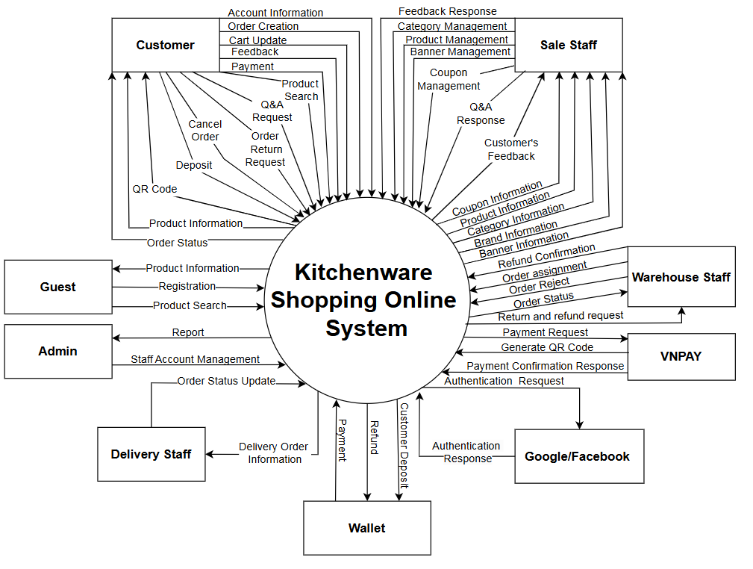

2. User Requirements

2.1 Actors
# | Actor | Description
1 | Admin | The admin has CRUD permissions for staff accounts and inherits all sale staff privileges. Additionally, the admin can access reports to analyze orders, customers, and products with filters by month, year, or other criteria as needed.
2 | Customer | A customer is an individual who has created an account on the website and can browse products, chat with sales staff, and make purchases.
3 | Guest | A visitor who browses the website without logging in can only view products and cannot make purchases.
4 | Sale Staff | Handles order processing and manages categories, brands, products, banners, coupons, and customer feedback/chat.
5 | Delivery Staff | View order information, ship goods, and update order status.
6 | Warehouse Staff | Prepare the order, then update the order status(approved/reject order).

2.2 Diagrams

2.2.1 UCs for Guest
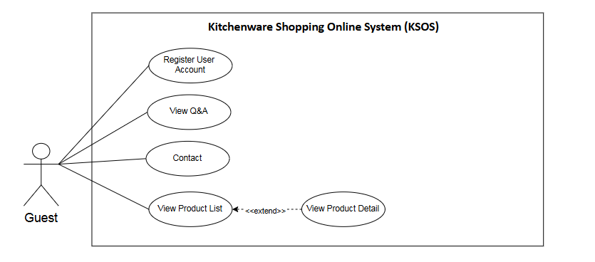

2.2.2 UCs for Common

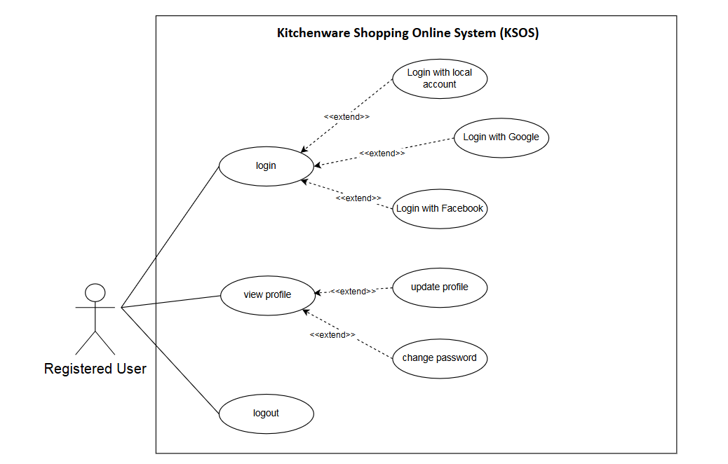

2.2.3 UCs for Customer
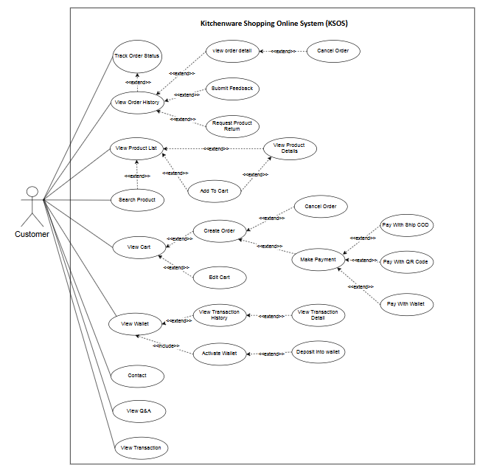

2.2.4 UCs for Sale Staff
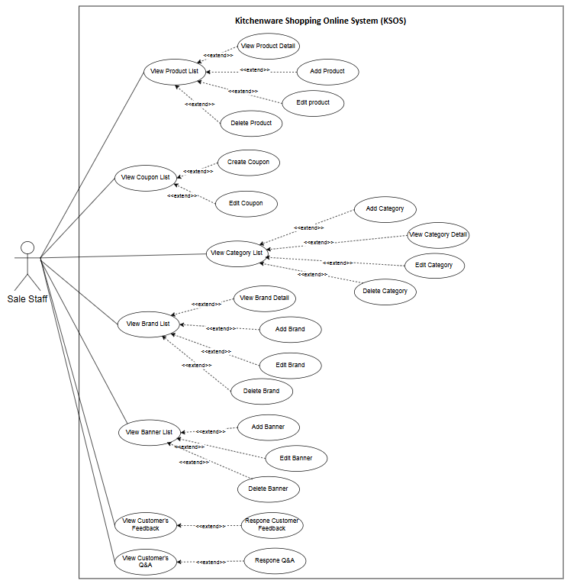

2.2.5 UCs for Delivery Staff
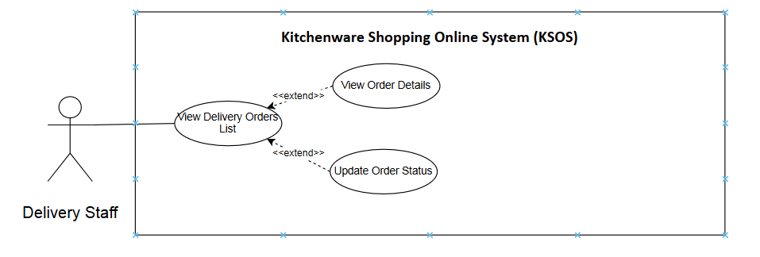

2.2.6 UCs for Warehouse Staff
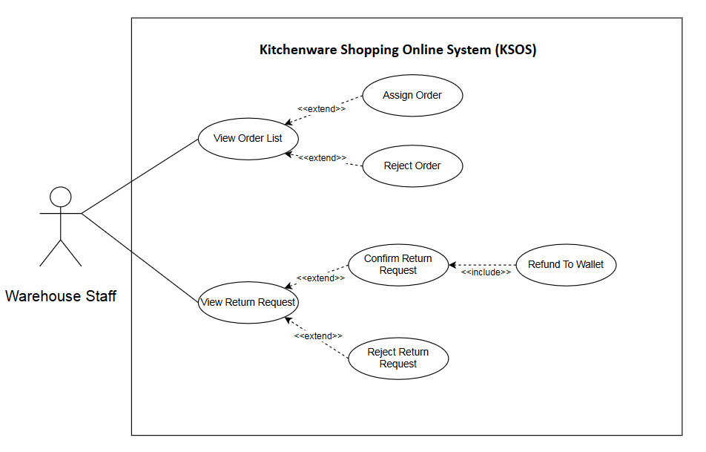

2.2.7 UCs for Admin
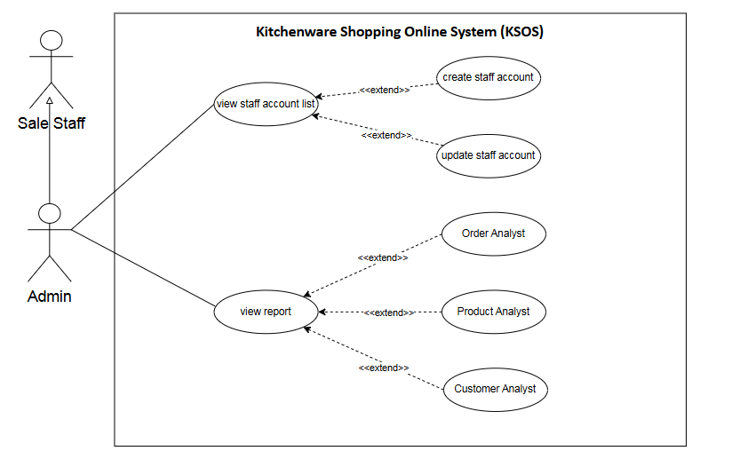

2.3 Descriptions

ID | Use Case | Actors | Use Case Description
01 | Register User Account | Guest | A guest user can create a new account in the system.
02 | View Product List | Guest, Customer, Sale Staff, Admin | Users can view the list of available products in the system.
03 | View Product Detail | Guest, Customer, Sale Staff, Admin | Users can select a product from the product list to view its detailed information
04 | Search Product | Customer, Guest | User can search for products using keywords or filters
05 | Add To Cart | Customer | Customers can add products to their shopping cart.
06 | View Order Detail | Customer | Customers can check detailed information about each order.
07 | Cancel Order | Customer | Customers can cancel their order if it has not been processed yet.
08 | View Order History | Customer | Customers can view their past orders.
09 | View Product Details | Customer | Customers can view detailed information about a product before purchasing.
10 | View Cart | Customer | Customers can check the products they have added to their cart.
11 | Edit Cart | Customer | Customers can modify their cart, including removing or updating product quantities.
12 | Create Order | Customer | Customers can add an order for the products in their cart.
13 | Make Payment | Customer | Customers can proceed with the payment for their order.
14 | Cancel Payment | Customer | Customers can cancel the payment for their order if needed.
15 | Track Order Status | Customer | Customers can check their order status.
16 | Submit Feedback | Customer | Customers can submit feedback on a product or service.
17 | Request Product Return | Customer | Customers can request a return for a purchased product in case of issues.
18 | View Wallet | Customer | Customers can check their wallet balance and transaction history.
19 | View Transaction History | Customer | Customers can view their past transactions.
20 | View Transaction Detail | Customer | Customers can check detailed information about a specific transaction.
21 | Deposit into Wallet | Customer | Customers can add funds to their wallet using various payment methods.
22 | Pay with Wallet | Customer | Customers can use their wallet balance to pay for orders.
23 | Pay With QR Code | Customer | Customers can make a payment using a QR code.
24 | Pay With Ship COD | Customer | Customers can choose to pay with Cash on Delivery
25 | Refund to Wallet | Customer | If an order is canceled, the refunded amount will be credited to the customer's wallet.
26 | Send Contact Request | Customer | Customers can send contact requests to provide feedback, ask questions, or report issues related to products, services, or other concerns.
27 | View Order List | Sale Staff, Admin | Sale staff and admin can see a list of all orders in the system.
28 | View Order Detail | Sale Staff, Admin | Sale staff and admin can check the details of a specific order.
29 | Edit Order Status | Sale Staff, Admin | Sale staff and admin can update the status of an order (e.g., pending confirmation, confirmed, canceled, delivered).
30 | Add Product | Sale Staff, Admin | Sale staff and admin can add products to the system.
31 | Edit Product | Sale Staff, Admin | Sale staff and admin can update product information.
32 | Delete Product | Sale Staff, Admin | Sale staff and admin can remove products from the system.
33 | View Coupon List | Sale Staff, Admin | Sale staff and admin can view all available coupons in the system.
34 | Create Coupon | Sale Staff, Admin | Sale staff and admin can create discount coupons.
35 | Edit Coupon | Sale Staff, Admin | Sale staff and admin can edit existing coupons.
36 | View Category List | Sale Staff, Admin | Sale staff and admin can see the list of categories.
37 | View Category Detail | Sale Staff, Admin | Sale staff and admin can check detailed information of a specific category.
38 | Add Category | Sale Staff, Admin | Sale staff and admin can create new categories.
39 | Edit Category | Sale Staff, Admin | Sale staff and admin can modify category details.
40 | Delete Category | Sale Staff, Admin | Sale staff and admin can remove categories.
41 | View Brand List | Sale Staff, Admin | Sale staff and admin can view all brands available in the system.
42 | View Brand Detail | Sale Staff, Admin | Sale staff and admin can check detailed information about a brand.
43 | Add Brand | Sale Staff, Admin | Sale staff and admin can add new brands to the system.
44 | Edit Brand | Sale Staff, Admin | Sale staff and admin can update brand details.
45 | Delete Brand | Sale Staff, Admin | Sale staff and admin can remove brands from the system.
46 | View Banner List | Sale Staff, Admin | Sale staff and admin can view all banners.
47 | Add Banner | Sale Staff, Admin | Sale staff and admin can create new banners.
48 | Edit Banner | Sale Staff, Admin | Sale staff and admin can modify banner details.
49 | Delete Banner | Sale Staff, Admin | Sale staff and admin can remove banners.
50 | View Customer Feedback | Sale Staff, Admin | Sale staff and admin can view feedback from customers.
51 | Respond Customer Feedback | Sale Staff, Admin | Sale staff and admin can reply to customer feedback.
52 | Reply Contact Request | Sale Staff, Admin | Sale Staff and Admin can respond to customer contact requests by providing replies through the system.
53 | View Delivery Orders List | Delivery Staff | Delivery staff can access a list of orders assigned for delivery.
54 | View Delivery Order Detail | Delivery Staff | Delivery staff can check detailed information about assigned deliveries.
55 | Update Order Status | Delivery Staff | Delivery staff can update the delivery status, such as out for delivery or delivered.
56 | View Order List | Warehouse Staff | Warehouse staff can check the list of customer orders.
57 | View Order Detail | Warehouse Staff | Warehouse staff can view detailed information about a specific order.
58 | Update Order Status | Warehouse Staff | Warehouse staff can update the status of an order.
59 | Reject Order | Warehouse Staff | Warehouse staff can reject an order.
60 | Assign Order | Warehouse Staff | Warehouse staff can assign an order for delivery.
61 | View Return Request | Warehouse Staff | Warehouse staff can check refund requests.
62 | Confirm Return Request | Warehouse Staff | Warehouse staff can approve return requests.
63 | Reject Return Request | Warehouse Staff | Warehouse staff can reject return requests.
64 | Refund To Wallet | Warehouse Staff | Warehouse staff verifies return requests and refunds the amount to the customer's wallet.
65 | View Staff Account List | Admin | The admin can view all staff accounts in the system.
66 | Create Staff Account | Admin | The admin can create new staff accounts.
67 | Update Staff Account | Admin | The admin can update staff account information.
68 | View report | Admin | The admin can view reports and statistics related to sales, revenue, and system activities.
69 | Login | Register User | Registered users can log into the system with their credentials or use social login (Google, Facebook).
70 | View Profile | Register User | Registered users can view their personal information.
71 | Update Profile | Register User | Registered users can update their personal details.
72 | Change Password | Register User | Registered users can change their login password.
73 | Logout | Register User | Registered users can log out of the system.

2.4 Main Workflows

Order Processing
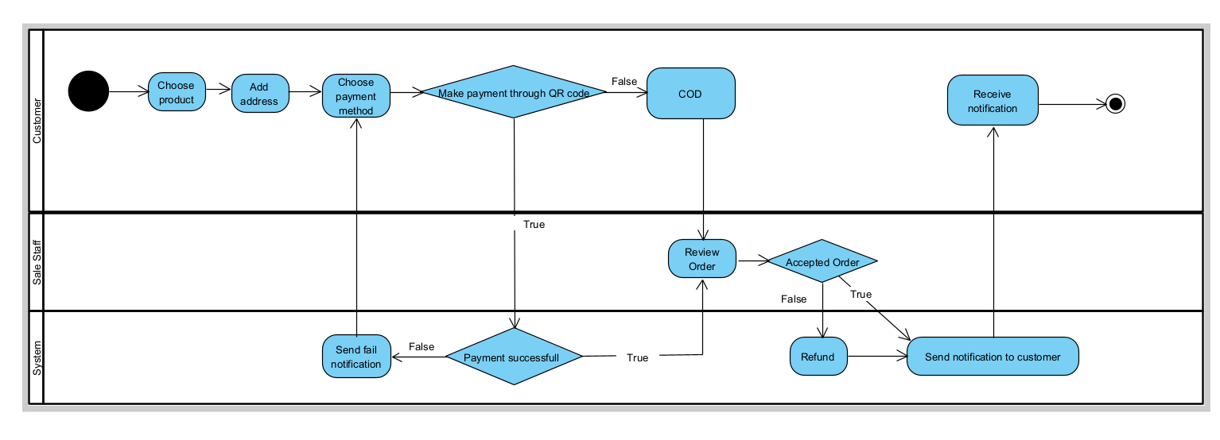

Delivery Processing
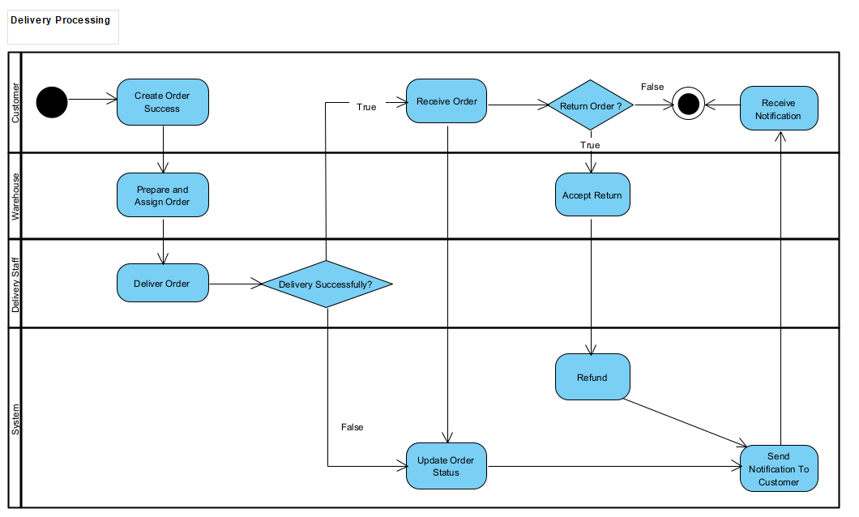

3. System Functionalities

3.1 Screens Flow
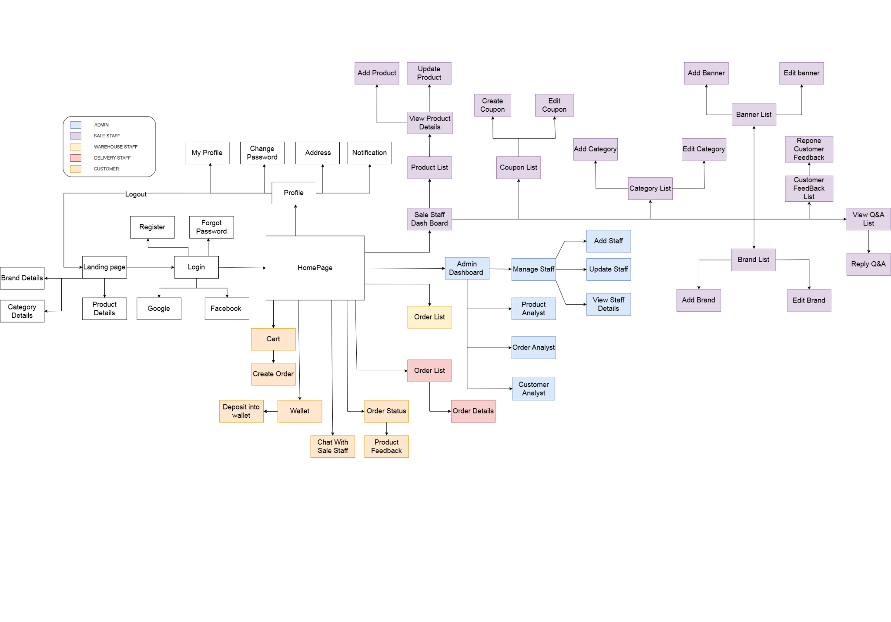

3.2 Screen Authorization

# | Screen/Function | Admin | Customer | Sale | Warehouse | Delivery | Guest
1 | landing Page |  | x |  |  |  | x
2 | Register |  |  |  |  |  | x
3 | Login | x | x | x | x | x | x
4 | Forgot Password | x | x | x | x | x
5 | Sign out | x | x | x | x | x
6 | Reset Password | x | x | x | x | x
7 | View Profile | x | x | x | x | x
8 | Change password | x | x | x | x | x | x
9 | Address |  | x
10 | Notification |  | x
11 | View Cart |  | x
12 | Order Tracking |  | x
13 | Create Order |  | x
14 | Wallet |  | x
15 | Deposit into wallet |  | x
16 | Staff Account Detail | x
17 | Staff Account List | x
18 | View Product List | x |  | x
19 | View Product Details | x |  | x
20 | Create Product | x |  | x
22 | Edit Product Details |  |  | x
23 | View Brand List | x |  | x
24 | Brand Detail | x |  | x
25 | Add new brand | x |  | x
26 | Update Brand Detail | x |  | x
27 | View Category List | x |  | x
28 | View Category Detail | x |  | x
29 | Add new category | x |  | x
30 | Edit Category | x |  | x
41 | Add banner | x |  | x
42 | Edit Banner | x |  | x
43 | View Banner List | x |  | x
44 | Coupon list | x |  | x
45 | Create Coupon | x |  | x
46 | Edit Coupon | x |  | x
47 | Feedback Product |  | x
48 | View Customer Feedback |  |  | x
49 | Reply Customer Feedback |  |  | x
50 | Chat With Sale Staff |  | x
51 | View Q&A List |  |  | x
52 | Reply Q&A |  |  | x

3.3Non-UI Functions

# | Feature | System Function | Description
1 | Security | Password Hashing | User passwords must be securely hashed using BCrypt before being stored in the database.
2 | Security | Authentication Method | The system uses Spring Security to authenticate users via username and password.
3 | Security | OAuth2 Login Support | The system supports OAuth2 login with Google/Facebook
4 | Security | Role-Based Access Control | The system implements role-based access control (Customer, Staff, Admin).
5 | Performance | Login Response Time | Authentication should take no longer than 2 seconds per login attempt.
6 | Performance | Real-time Notification | The system provides real-time notifications

II. Functional Requirements

1. Common Function

1.1 Sign-In Screen
Function Description
- Purpose: Allows registered users to authenticate and gain access to the system.
- How It’s Called:
  - Accessed via the URL /sign-in.
  - Triggered by clicking the "Log In" button or a similar link on the home page.

Screen Layout
- Input Fields:
  - Username: Username (required).
  - Password: Password (required).
- Action Buttons:
  - Log In: Submits the authentication request.
  - Forgot Password: Link to reset the password.
- Other Login Options:
  - Sign in with Google.
  - Login with Facebook.
- Error Messages:
  - Display errors if the username or password is incorrect.
  - 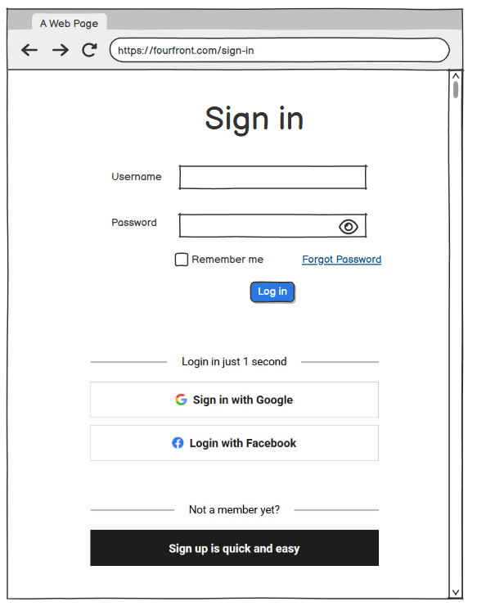

1.2 Register Screen
Function Description:
- Purpose: Allows new users to create an account by entering personal information and setting a password.
- How It’s Called:
  - Accessed via the URL /register
  - Usually triggered when the user clicks on the "Register" link or button on the Sign-In screen.
Screen Layout
- Input Fields:
  - User Name: Username (required) must not contain blank, special character, min length = 4.
  - First Name: First name (required) must contain the alphabet only.
  - Last Name: Last name (required) must contain the alphabet only.
  - Date of Birth: Date of birth in the format mm/dd/yyyy (required), the age of the user must be greater than 18 .
  - Sex: Gender selection (dropdown, required, the sex must be only male or female
  - Email: A valid email address (required), the format must be right for email format localpart@domain
  - Password: Password (required), the password must not be empty, min length = 5
  - Repeat your password: Confirm password (required), the confirm password must be the same as the password
  - Avatar: (not required), any image format, any size
- Action Buttons:
  - Register: Submits the sign-up request.
- Error Display Rules:
  - Show error messages if any field is left empty or contains invalid data.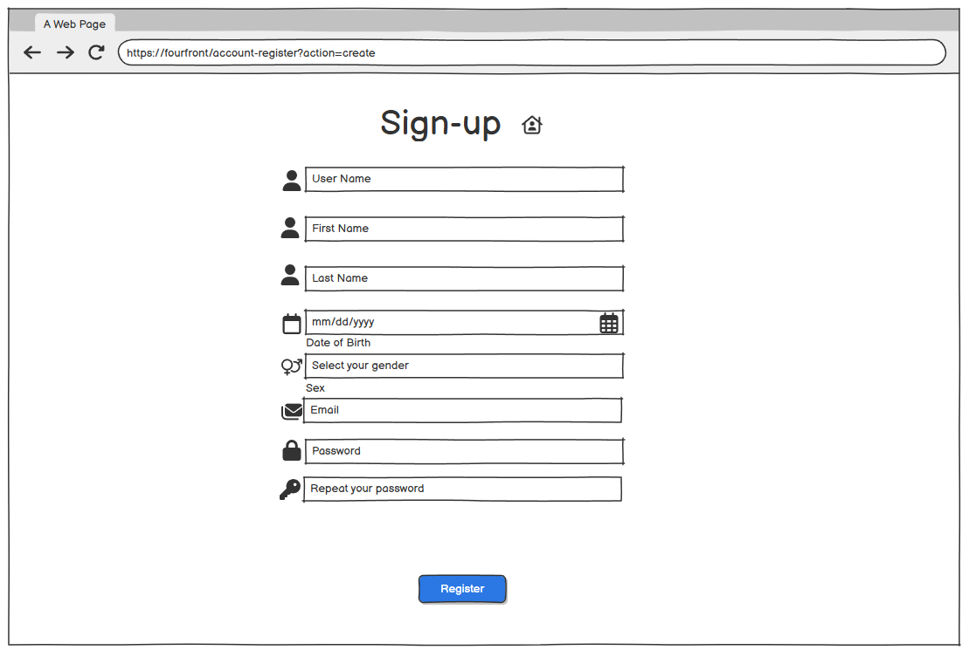

1.3. Reset Password
Function Description
- Purpose: The "Reset Password" feature is provided to assist users in recovering their passwords in case they forget or lose their passwords.
- How It’s Called:
  - Users can access this feature in the following cases:
    - On the login screen: Users click on the "Forgot Password?" link on the login screen.
    - On the registration page: Users can find the "Reset Password" link in the account support information section.

Screen Layout
- Input Fields:
  - Email (required):
    - Users must enter their registered email address.
    - Email must be in a valid format localpart@domain
- Action Buttons:
  - Receive Email: Sends a one-time password (OTP) to the provided email.
- Error Display Rules:
  - When attempting to access a page that requires authentication but fails to log in, the "Reset Password" link will be displayed along with an error message.
Reset password in screen:
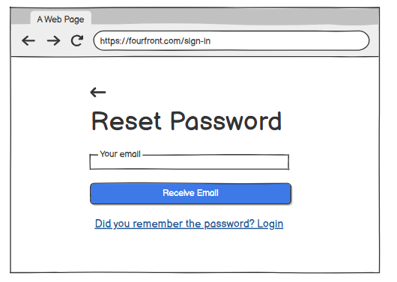

1.4 Home screen
Function Description
- Actor: Guest, Customer.
- Purpose:
  - The Home screen allows customers to search for products easily and filter by brand, category, and price(example price 0-100, 100-200).
- Button: Click on the button [search] after selecting the desired filter.

How It’s Called:
  - Customers, guests are directed to the "Home" screen immediately upon visiting the website (https://fourfront.com/home).
  - Customers can also return to this screen by clicking the "FourFront" logo at the top-left corner of the page from any other section of the site.
Screen Layout
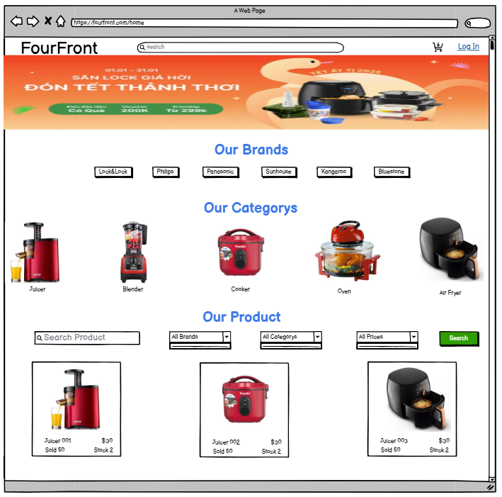

1.5 Profile

1.5.1 View Profile
Function Description
- Purpose: Display detailed user profile information, including username, name, email, and gender.
- How It’s Called:
  - Accessed via the URL /profile or when a user navigates to the Profile page via the sidebar menu or the dropdown menu in the top-right corner.

Screen Layout
- Header: Displays the title "My Profile" in a large font.
- Header icon: Quick access icons for user notifications and profile options in the top-right corner.
- Sidebar Menu: Provides navigation to different sections of the user account, such as Dashboard, Address, Orders, Edit Profile, and Change Password, allowing quick access to key functionalities.
- Avatar Profile: A profile picture placeholder.
- Fields: Profile Information:
  - Username: The user’s unique username.
  - First Name: The first name of the user.
  - Last Name: The last name of the user.
  - Email: The user’s registered email address.
  - Sex: The user’s gender (Male/Female).
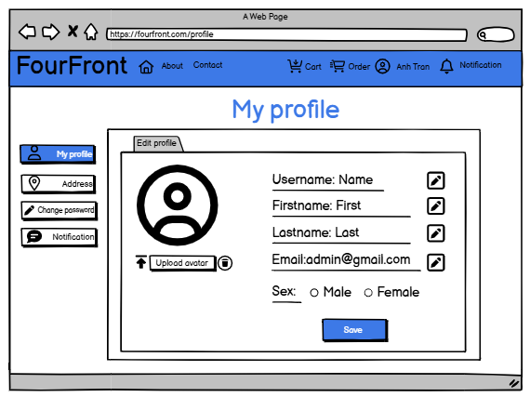

1.5.2 Edit Profile
Function Description
- Purpose: Allows users to view and update their personal information directly from the profile page.
- How It’s Called: Accessed when a user clicks the Edit Profile button on the Profile page.
- Business Rules:
  - Users must be logged in to edit their profile.
  - First name & Last name: Cannot be empty or contain only spaces. They must only include letters, numbers, and spaces (no special characters).
  - Email: Cannot be empty and must follow a valid email format (e.g., example@domain.com).
  - Display error messages for invalid inputs.

Screen Layout
- Header: Displays the title "My Profile" in a large font.
- Header icon: Quick access icons for user notifications and profile options in the top-right corner.
- Sidebar Menu: Provides navigation to different sections of the user account, such as Dashboard, Address, Orders, Edit Profile, and Change Password, allowing quick access to key functionalities.
- Avatar: Allows users to upload a profile picture.
- Buttons:
  - Save: Confirms changes and updates the user’s profile.
- Error Messages:
  - Display an error message if any required field is empty, incorrectly formatted, or if an update failure occurs.
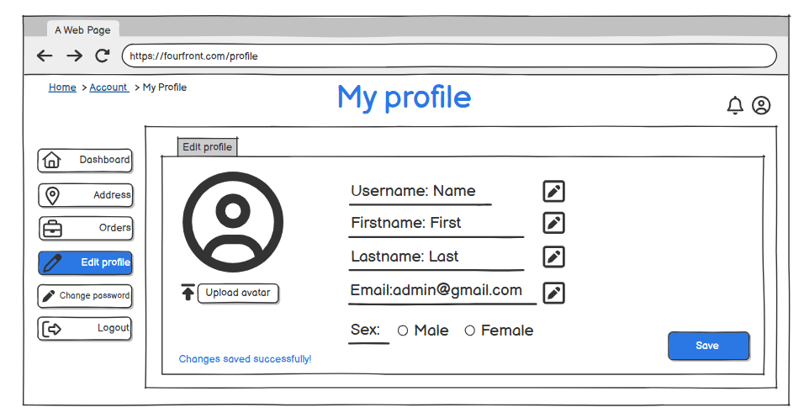

1.6 Logout
Function Description
- Purpose:
  - Allow users to securely log out of their account.
  - Prevent unauthorized access after logging out.
  - Ensure sessions or tokens are properly invalidated.
- How It’s Called:
  - Accessed via the URL: /logout.
  - Triggered when the user clicks the Logout button in the dropdown menu.
- Business Rule:
  - The logout option is placed inside a dropdown menu under the profile icon in the header.
  - The user must be logged in to perform logout.
  - After successful logout, the user is redirected to the homepage.

Screen Layout
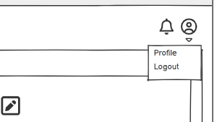

1.7 Change Password
Function Description
- Actors: Customer, Staff, Admin

Purpose: Replace current password by a new password

How It’s Called: Accessed via the URL /profile/change-password
- Business Rule:
  - Current Password: Required, must match old password.
  - New Password: Required, min 8 characters. Weak if only letters/numbers, strong if includes symbols.
  - Confirm Password: Required, must match new password.
  - Submission: Only allowed if all fields are valid.

Screen Layout
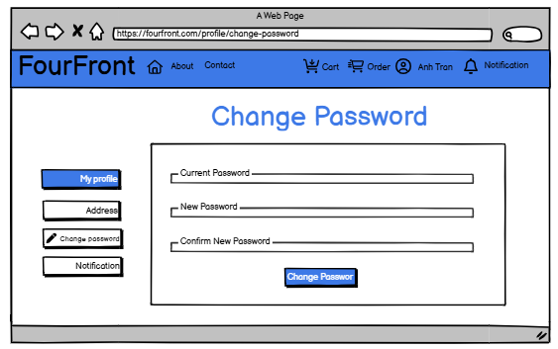

1.8 Address
Function Description

Purpose:
  - Identifying the delivery location – Helps the shipping provider know exactly where to deliver the order.
  - Manage user shipping addresses, including adding, editing, and deleting addresses.

How It’s Called:
  - Users access the Profile section via the Profile icon in the header.
  - In the Profile menu, users select the Address option to manage their saved addresses.
- Business Rules:
  - ReceiverName: The recipient's full name, used for delivery purposes, Required (Cannot be empty).
  - ReceiverPhone: The recipient's contact phone number for order confirmation
    - Required (Cannot be empty).
    - Must be exactly 10 digits.
    - Must start with a valid prefix: 03, 05, 07, 08, 09.
  - HouseNumber: The specific house number of the recipient, Required (Cannot be empty).
  - Province/City: The province or city where the recipient's address is located.
    - Required (Cannot be empty).
    - Must be selected from the predefined list
  - District: The district within the selected province/city where the recipient resides.
    - Required (Cannot be empty).
    - Must match the selected province/city.
    - Must be selected from the predefined list
  - Ward: The ward within the selected district where the recipient resides.
    - Required (Cannot be empty).
    - Must match the selected district.
    - Must be selected from the predefined list
  - Save Address Button:
    - When the user clicks the save button, if all fields are valid, show a success message: 'Address added successfully!' (for creation) or 'Address updated successfully!' (for edit).

Screen Layout
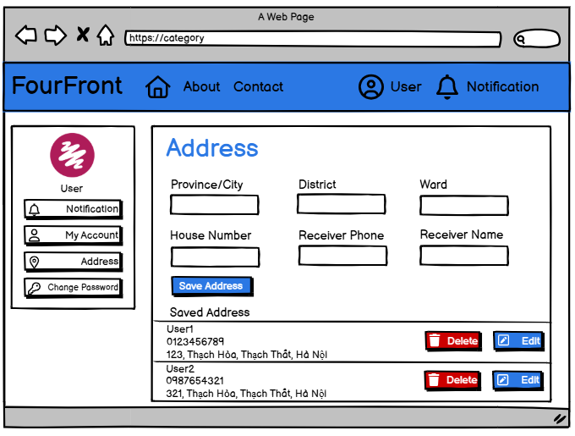

1.9 Notification
Function Description

Purpose:
- Show all notifications of an user (customer, staff)
- View new unread notifications in header dropdown section

How It’s Called: Accessed via the URL /notifications

Screen Layout
- Fields:
  - Title: the title of the notification, the overview of content
  - Content: the detail of the notification
  - Time: time when the notification sended to the user
  - Status: read and unread
  - Mark as all read button: make all notifications would be read, so that all notifications will disappear on the header dropdown
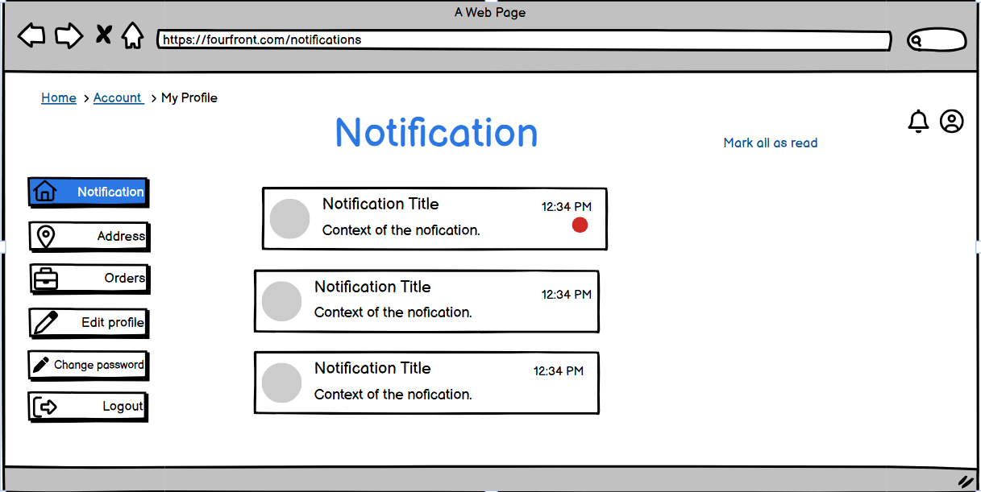

1.10 Contact
Function Description
- Purpose: Allow customers to view Frequently Asked Questions (FAQ) and send messages to the support team via a contact form displayed on the contact page.

How It’s Called: Accessed by clicking the Contact button in the header

Screen Layout
- Fields:
  - Header Section:
    - Title: Need Help? Contact Us!
    - A Contact Us button that, when clicked, displays a contact form directly
  - Frequently Asked Questions (FAQ):
    - Displayed in a collapsible format.
    - Each question can be clicked to reveal or hide its corresponding answer.
  - Contact Form (Accessed via Contact Us Button):
    - Name: The name of the user making the request.
    - Email:The email address of the user for communication purposes.
    - Title: A brief summary of the user's inquiry.
    - Message: The detailed message or inquiry from the user.
    - Send Message: (Button)- Sends the message to the support team.
    - Cancel: (Button) - Hides the contact form.
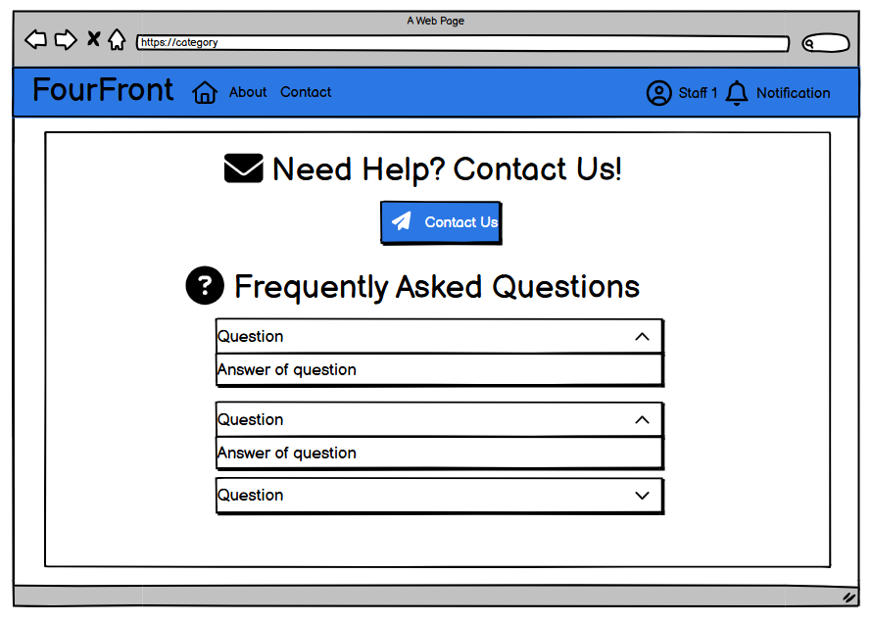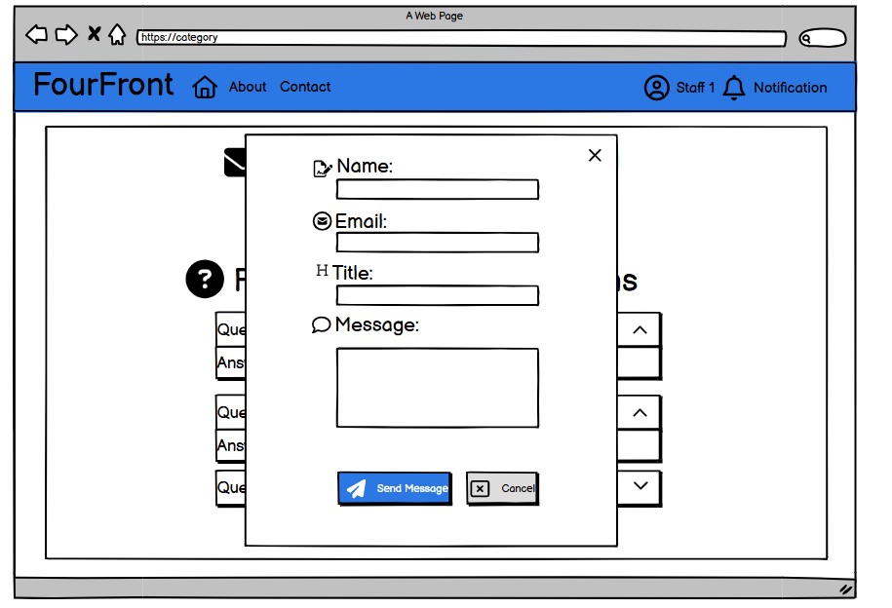

2. Customer Function:

2.1. Cart
Function Description

Purpose:
- Identifying the item – Helps the user can choose their product which they want to buy and that product’s quantity in cart item
- Calculating total of order –The system will calculate the total all items in the cart help
How It’s Called: Accessed via the URL /cart
Screen Layout
Fields:
  - Item image: Image of the product of each item
  - Product name: Name of the product of each item
  - Price: Price of the product of each item
  - Quantity: Input field for the user to enter the quantity of each item ( >= 1 )
  - Subtotal: Total of each cart item ( quantity * product price )
  - Delete Button:Button to delete the cart item .
  - Total: Total of all items in the cart
  - Order Button: A primary button to create an order
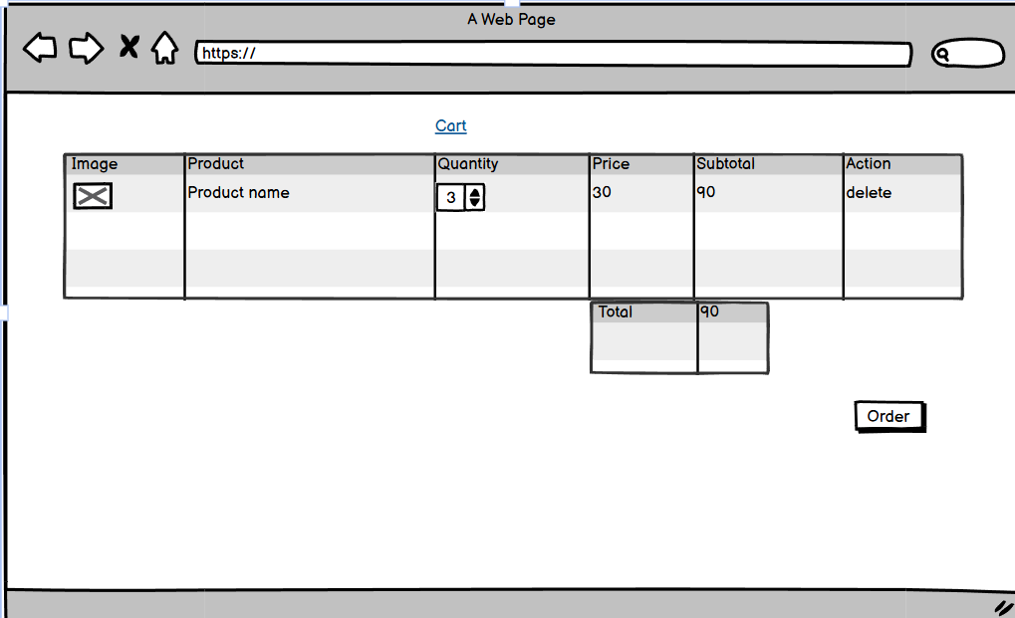

2.2 Wallet

2.2.1. Wallet manager page
- Function description:
  - Actor: Customer
  - Purpose: To view information about wallet of customer
  - How It’s Called: url /wallet
  - Business rule:
    - Balance: must be non negative, show the balance of wallet
    - Active Button: will available when the wallet is not active, to unlock the wallet
    - Inactive Button: will available when the wallet is inactive, to lock the wallet
    - Change passcode button: will available when the wallet is active, to change the passcode of wallet
    - Deposit: will available when the wallet is active, to deposit into the wallet
- Prototype:
  - Active wallet
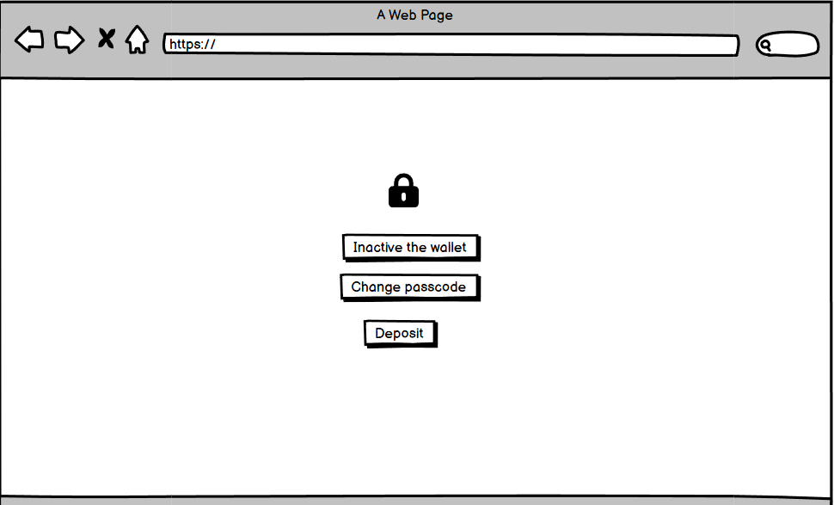

  - Inactive wallet
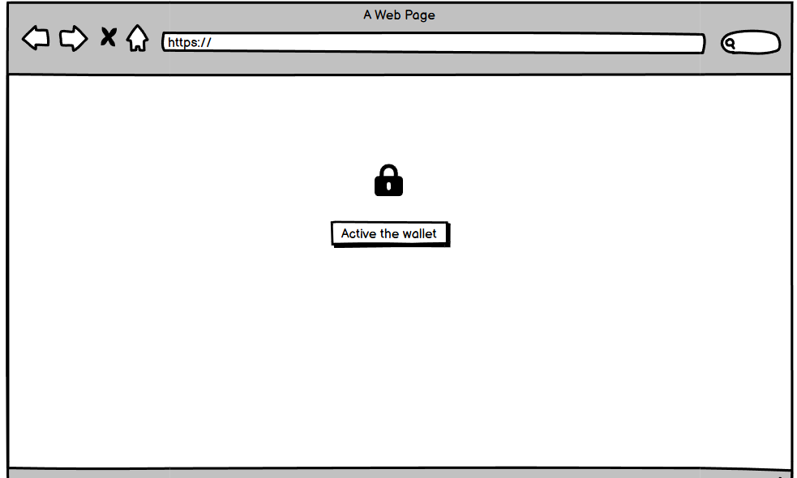

2.2.2. Active wallet
- Function description:
  - Actor: Customer
  - Purpose: To active the wallet
  - How It’s Called: url /wallet/active
  - Business rule:
    - Verification code: must an 6 length random string, user has to be enter right code to active and set the passcode
    - Verification button: button to submit the verification code
    - Resend code link: link to resend the code when something wrong or user enter code after 120 seconds
- Prototype:
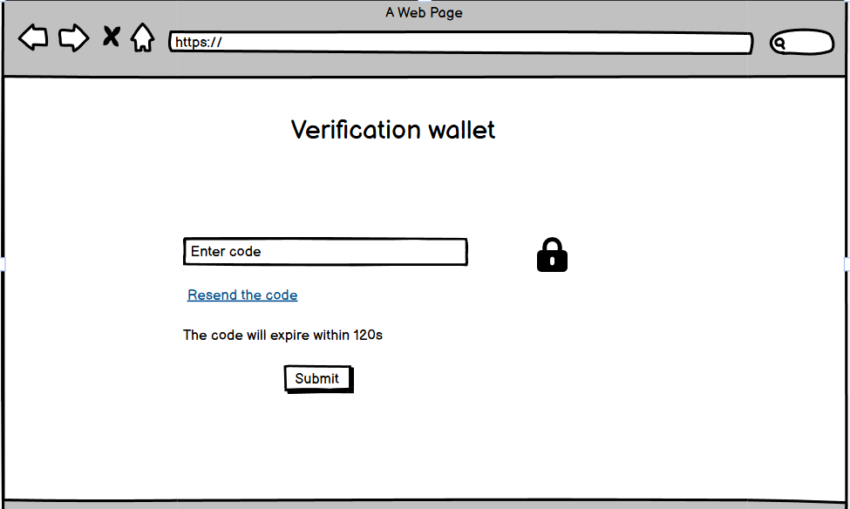

2.2.3. Change passcode wallet
- Function description:
  - Actor: Customer
  - Purpose: to change the passcode of wallet
  - How It’s Called: url /wallet/change-passcode
  - Business rule:
    - old password: the previous password of the wallet, user has to enter right password to change , must be 6 digit passcode
    - new password: new password of the wallet, must not be blank, must be 6 digit passcode
    - confirm password: repeat new password of the wallet, must be the same the new passcode
    - Change password button: submit button to change the password
- Prototype:
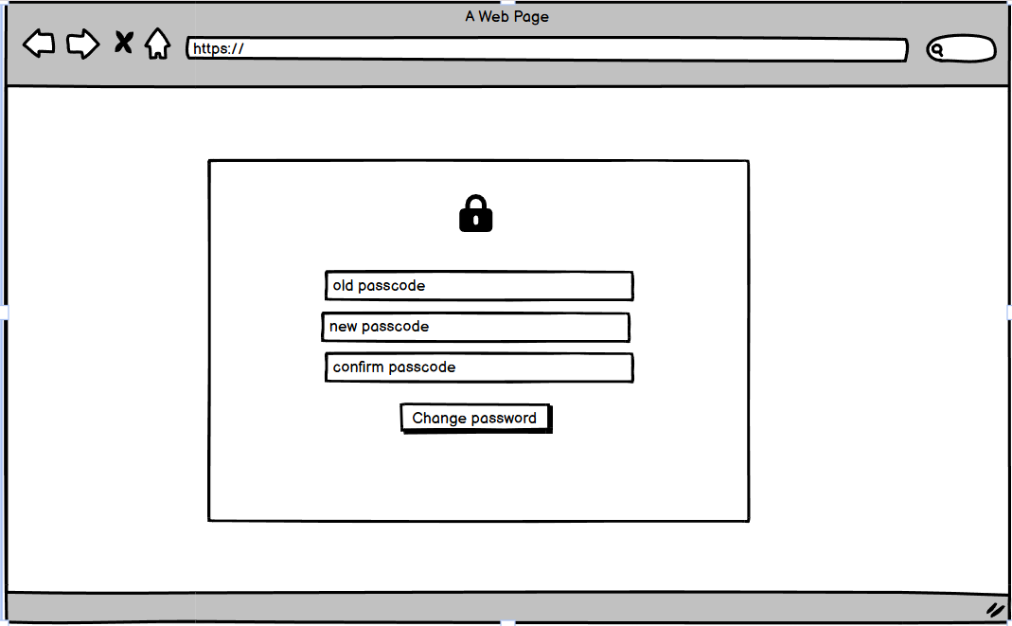

2.2.4. Deposit into wallet
- Function description:
  - Actor: Customer
  - Purpose: To view information about wallet of customer
  - How It’s Called: url /wallet/ , click to the deposit button
  - Business rule:
    - amount: the amount user want to deposit into the wallet, it must be greater than 0 vnd
    - deposit button: button to send to deposit money request, it will redirect to the Viet QR web to deposit
    - cancel button: button to cancel the deposit request
- Prototype:

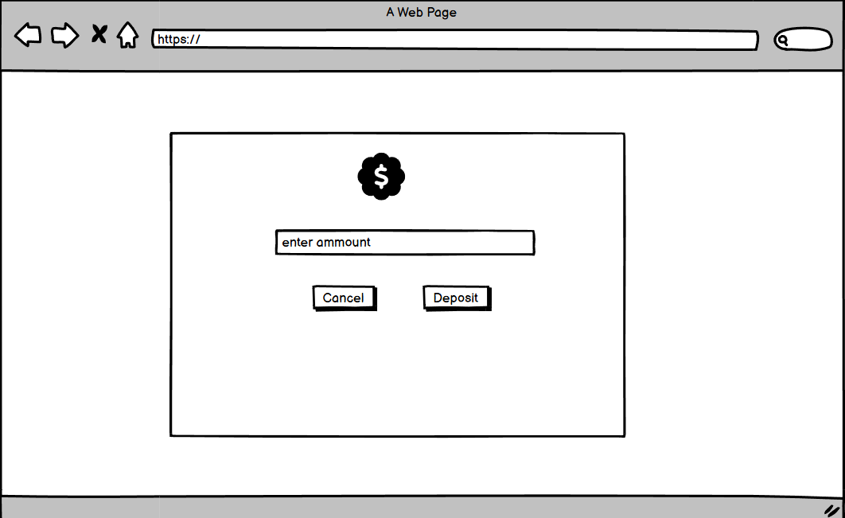

2.3. Order

2.3.1. Create Order
- Function description:
  - Actor: Customer
  - Purpose: To create a new order
  - How It’s Called: click the order cart in cart page
  - Business rule:
    - Cart items list must not be empty
    - Address: (required) the address for delivery, if user don’t have any address, request user to add to new address
    - Coupon: (not required) user choose an available coupon for the order
    - Payment Method: (required)
      - COD: user pay by cash when he/she get the order by delivery staff
      - Wallet: user pay by the system wallet in case the balance wallet is greater than value of order or else will be disable this choice
      - QR: user use banking app to scan QR code for transaction to pay for the order
    - Submit button: when all above condition are meet, the submit button will be enable
- Prototype:
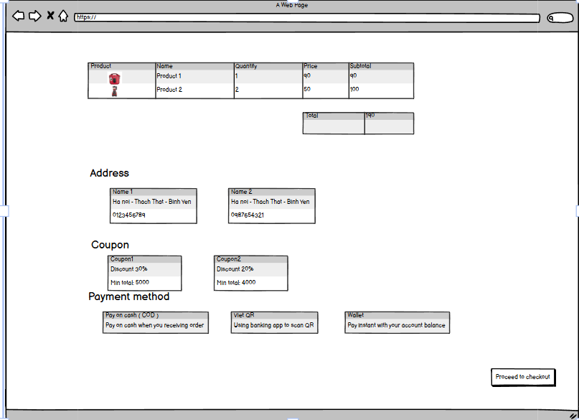

2.3.2. Cancel Order
- Function description:
  - Actor: Customer
  - Purpose: To cancel a unpaid or to ship order
  - How It’s Called: click the cancel button on order view page
  - Business rule:
    - Cancel order button: only available when order is unpaid or the delivery staff hasn’t delivery,
    - Confirm form: will display when user click the cancel button, which ask user that confirm to cancel this order:
      - Yes, cancel the order : the order will be cancelled
      - Close: close the cancel confirmation form, the order won’t be cancelled
- Prototype:

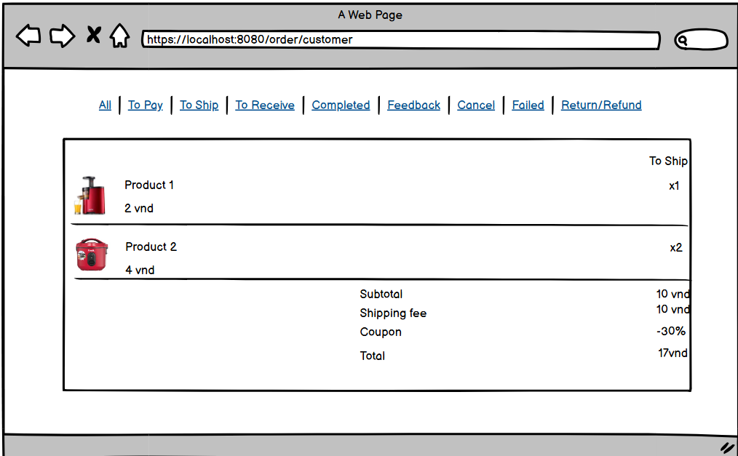
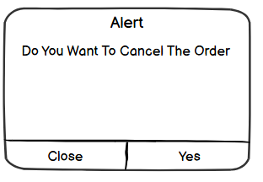

2.3.3. View Order List
- Function description:
  - Actor: Customer
  - Purpose: show all orders that the customer has work with, so that they can manager all their orders
  - How It’s Called:/order/customer or click on order button on navigation bar
  - Business rule:
    - Navigation order status:
      - All : will display all order of customer
      - To Pay: will display all order which that hasn’t been paid by customer
      - To Ship: will display all order what has been paid and being processed by staff ( approve/reject)
      - To receive: will display all order that has been approved by the staff and being deleverying
      - Completed: will display all order that has been delivery successful by staff
      - Failed: will display all order that is failed, because the staff reject the order or the order has not been delivery successful
      - Feedback: will display all order that has been feedback by the customer
      - Return/Refund: will display all order that the customer request to return the order because of some reason
- Prototype:
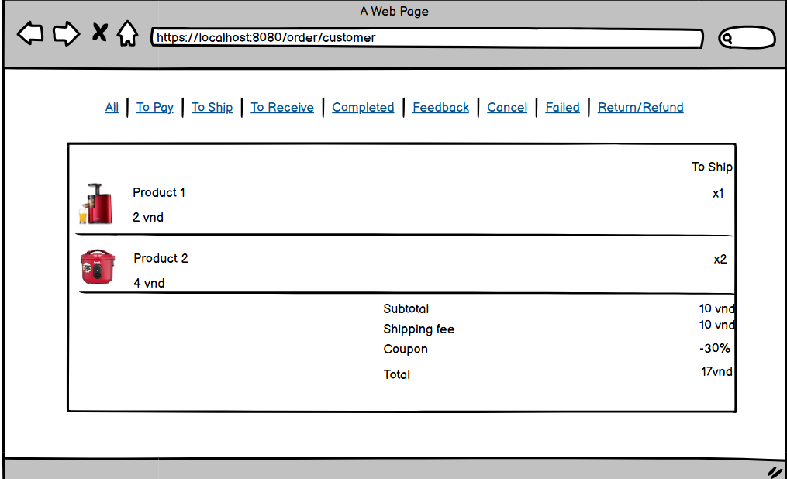

2.3.4. PayOS Payment
- Function description:
  - Actor: Customer
  - Purpose: To provide the customer platform to pay the order, customers can use their banking app to scan the QR and transfer money to pay for the order. This function using VietQR(PayOS) to generate QRCode and process the order
  - How It’s Called: User choose the payment method is QRCode to using this function
  - Business rule:
    - The redirect to the QR page button: When the user click on this button, the system will redirect user to the QR page, so that they can scan QR Code to pay
    - Cancel button: Click to cancel the payment process
- Prototype:
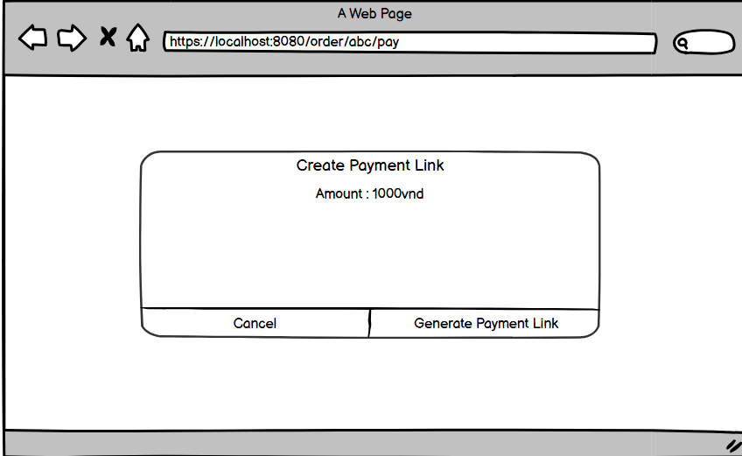

2.3.5. Wallet Payment
- Function description:
  - Actor: Customer
  - Purpose: Provide the customer the wallet payment to pay to order. To use this function, the wallet’s balance must not be smaller than the total of the order and the wallet has been activated. To pay, customer must enter the right passcode of the wallet or else the payment will be failed
  - How It’s Called: User choose the payment method is wallet to using this function ( the wallet option will be available only when the wallet is activated and the wallet’s balance is greater than total of order)
  - Business rule:
    - Password: A 6 digit length passcode, which is the passcode of wallet. If enter wrong the passcode the system will display the error message
    - Submit: When the user clicks on this button, the system will check the passcode. If the passcode is true, the system will redirect to the customer order page, else the system will display error message
    - Cancel button: Click to cancel the payment process
- Prototype:
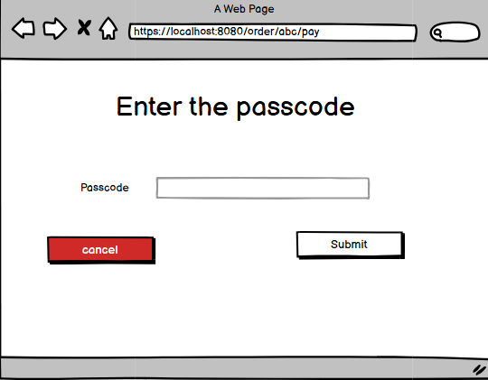
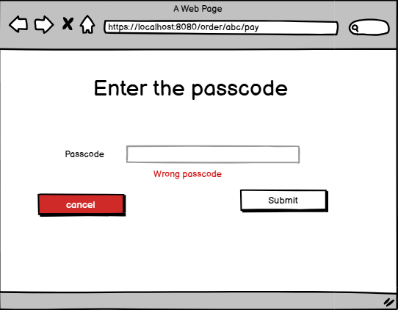

2.3.6. Feedback Order
- Function description:
  - Actor: Customer
  - Purpose: After the order is completed, the customer will be able to feedback about the order ( vote, comment, images )
  - How It’s Called: On the customer order list page, choose the order which has status equal to “Completed”, on each order item will has the feedback button.
  - Business rule:
    - Rating(required): the number of star of the item from 1(lowest) to 5(highest), which will evaluate the satisfaction of the customer about that item
    - Comment: the description of item, which length not longer than 2000 characters
    - Images: the image of item which is taken by customer
    - Submit: after click this button, the feedback will be posted
- Prototype:

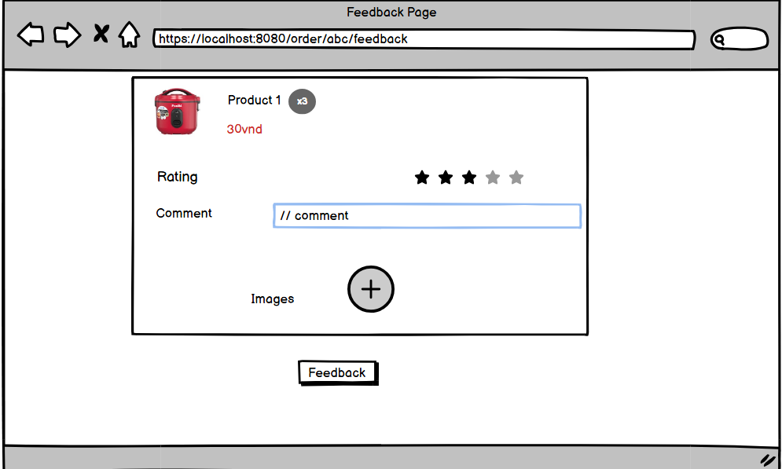

2.3.7. Order Detail
- Function description:
  - Actor: Customer
  - Purpose: view all detail information about their own order
  - How It’s Called: Click on the order item in order customer list page or via link
/order/{id}
  - Fields :
    - Item list:
      - Status: current status of this order
      - Item :
        - Product name : product name of each item
        - Item quantity: quantity of each item
        - Product price: price of each item
      - Feedback ( if customer has feedback ) :
        - Time: time of feedback
        - Vote: vote of each feedback ( from 1 to 5 start )
        - Comment (optional): customer’s comment of the each item
        - Images (optional): customer’s feedback images
      - Subtotal : sum total of all item list
      - Coupon ( if applied ): discount percent of this order
      - Shipping fee: fee of shipping of order
    - Shipping information:
      - Receiver name: the name of person who will receive the order
      - Phone number: the phone number which will receive the order
      - Address: house number, house number, ward, district, province
    - Order timeline:
      - Status item:
        - Status value: the value of history status ( to pay, to ship, to receive, completed, failed, etc )
        - Description: the description of status
        - Time: update time of the status
    - Payment detail:
      - Payment method: The method of payment (Wallet, PayOS, COD)
      - Payment status: The status of payment ( pending, cancel, paid, etc )
      - Amount: amount of payment ( equal total of this order )
      - Time: time of payment (last update time)
- Prototype:
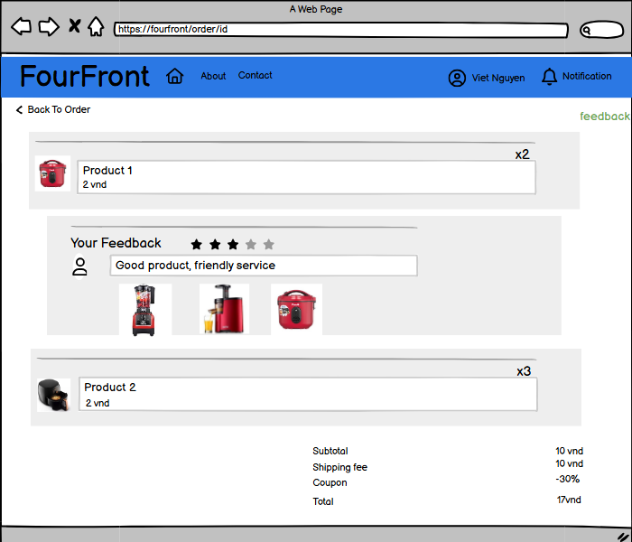

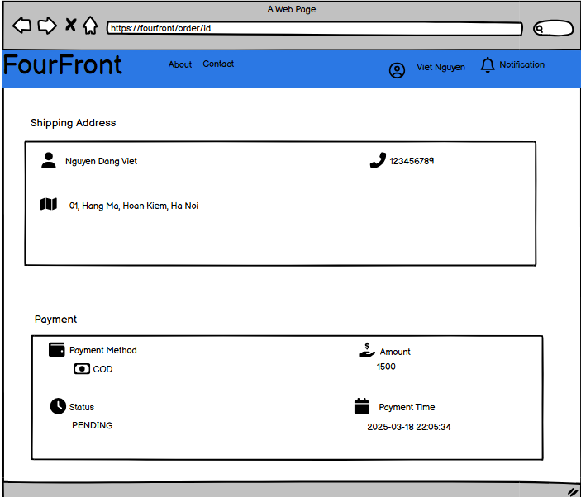
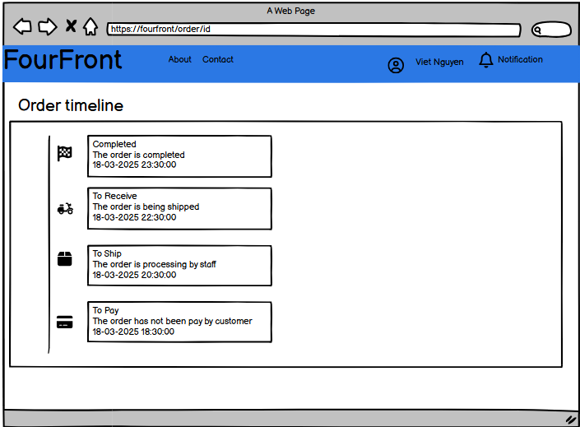

3. Sale Staff Function

3.1 Category

3.1.1 View All Category
  - Function description:
    - Actor: Admin, Sale Staff
    - Purpose: Display a list of all categories in the system. Admin, Sale Staff can view, edit, or delete categories, and add new categories when needed.
    - How It’s Called: Admin and Sale Staff selects the "Category Management" option from the DASHBOARD.
    - Business rule:
      - Dashboard Sidebar: The sidebar is always visible for Admin, Sale Staff to navigate between different management sections:
        - Brand Management
        - Category Management
        - Product Management
        - Coupon Management
      - Category Information Displayed:
        - Image: Displayed as an icon representing each category.
        - Name: The name of the category.
        - Description: A brief description of the category.
      - Buttons and Actions:
        - Detail Button: Displays detailed information about the category.
        - Edit Button: Allows editing of category information.
        - Delete Button: Allows deletion of a category. A confirmation prompt will appear before deleting.
        - Add Category Button: Redirects to the Add Category page to create a new category.
  - Prototype:

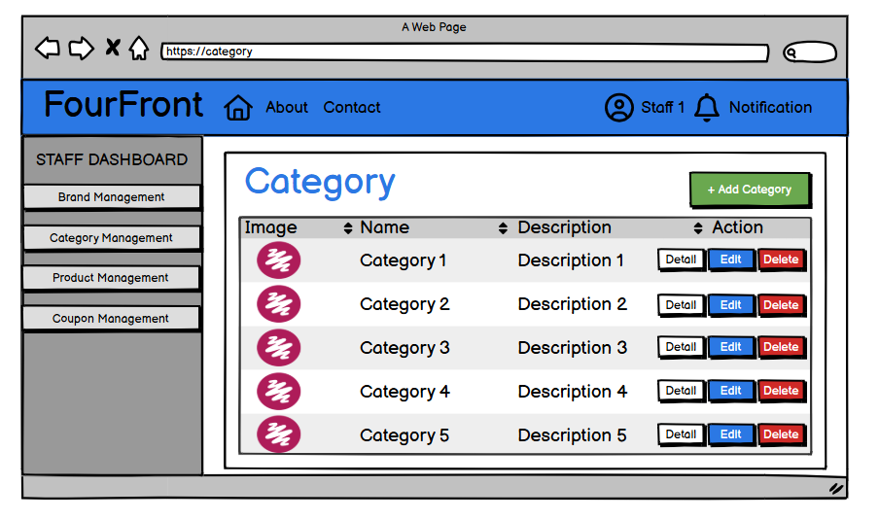

3.1.2 View Detail Category
  - Function description:
    - Purpose: Display detailed information about a specific category along with the list of products belonging to that category.
    - How It’s Called:
      - Staff clicks the "Detail" button from the Category List Page.
      - The system retrieves and displays all relevant information about the selected category.
    - Business rule:
      - Category Information Displayed:
        - Category Name: Displayed prominently at the top.
        - Category Image: Displayed as a representative icon or image for the category.
        - Description: A detailed description of the category.
      - Breadcrumb Navigation: Shows the current path (Category/Category1) to help users easily navigate back to the category list.
      - Product List Table:
        - Columns:
          - Image: An icon or thumbnail representing the product.
          - Name: The name of the product.
          - Category: The category to which the product belongs.
          - Action: A Detail button to view more information about each product.
  - Prototype:
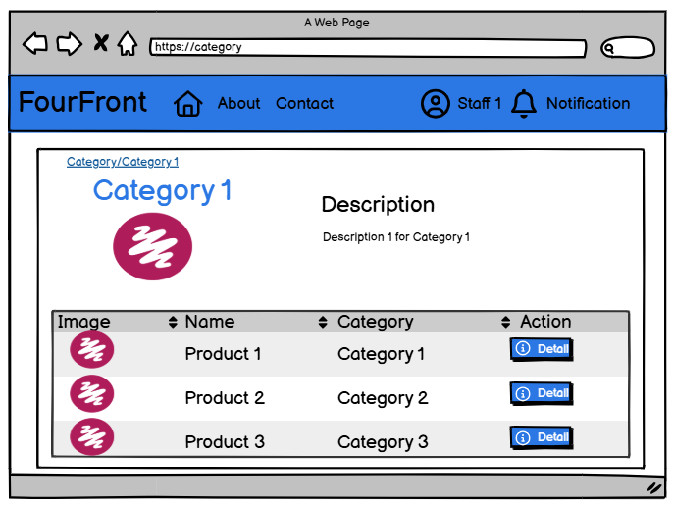

3.1.3 Edit Category
  - Function description:
    - Actor: Admin, Sale Staff
    - Purpose: Allow Admin, Sale Staff to update the information of an existing category, including name, description, and image.
    - How It’s Called:
      - Admin, Sale Staff clicks the "Edit" button from the Category List Page.
      - The system retrieves the current information of the selected category and displays it for editing.
    - Business rule:
      - Dashboard Sidebar: The sidebar is always visible for Admin and Sale Staff to navigate between different management sections:
        - Brand Management
        - Category Management
        - Product Management
        - Coupon Management
      - Editable Fields:
        - Name: Text input to modify the category name.
        - Description: Text area to update the category description.
        - Upload New Image:
          - Allows staff to upload a new image file as the category's representative image.
          - If no image is uploaded, the current image remains unchanged.
      - Breadcrumb Navigation: Shows the current path (Category/Edit) to help users easily navigate back to the category list.
      - Buttons:
        - Save:
          - When clicked, the system updates the category with the new information.
          - If successful, redirects back to the Category List Page with updated information displayed.
        - Cancel:
          - Cancels the edit operation and redirects back to the Category List Page without making changes.
      - Validation:
        - All required fields (Name, Description) must be filled.
        - Name must be validated to ensure it is between 3 and 255 characters and trimmed of unnecessary whitespace.
        - If invalid, the system will display an error message indicating the issue.
  - Prototype:
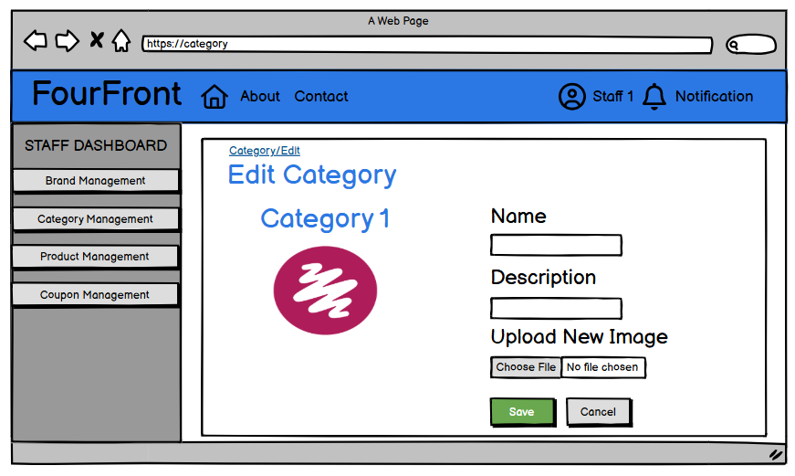

3.1.4 Add Category
  - Function description:
    - Actor: Admin, Sale Staff
    - Purpose: Allow Admin, Sale Staff to add a new category to the system, including name, description, and image.
    - How It’s Called:
      - Admin, Sale Staff clicks the “+ Add Category” button from the Category Management
    - Business rule:
      - Dashboard Sidebar: The sidebar is always visible for Admin, Sale Staff to navigate between different management sections:
        - Brand Management
        - Category Management
        - Product Management
        - Coupon Management
      - Breadcrumb Navigation: Shows the current path (Category/Add) to help users navigate back if needed.
      - Fields:
        - Name: Text input for entering the category name.
        - Description: Text area for providing details about the category.
        - Image: File upload option to choose a representative image for the category.
      - Buttons:
        - Add Category:
          - When clicked, the system attempts to create a new category with the provided details.
          - If successful, displays a success message on the page.
      - Validation:
        - All required fields (Name, Description, Image) must be filled.
        - Name must be validated to ensure it is between 3 and 255 characters and trimmed of unnecessary whitespace.
        - If invalid, the system will display an error message indicating the issue.
        - If no image is uploaded, the system will display an message asking the user to upload an image.
  - Prototype:
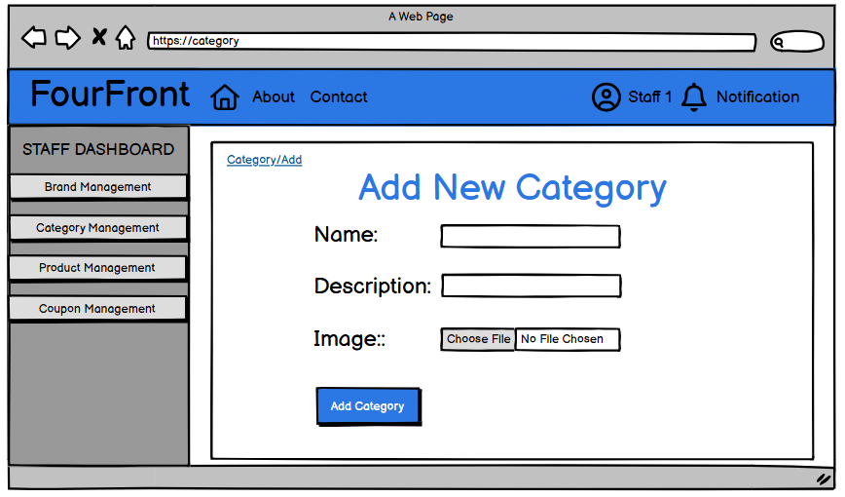

3.2 Brand

3.2.1 View All Brand
Function Description
- Actor: Admin, Sale Staff
- Purpose: Display a list of all brands in the system. Admin, Sale Staff can view, edit, or delete brands, and add new brands when needed.
- How It’s Called: Admin and Sale Staff selects the "Brand Management" option from the DASHBOARD.
Business Rules
- Dashboard Sidebar: The sidebar is always visible for Admin, Sale Staff to navigate between different management sections:
  - Brand Management
  - Category Management
  - Product Management
  - Coupon Management
- Brand Information Displayed:
  - Image: Displayed as an icon representing each brand.
  - Name: The name of the brand.
  - Origin: The country of origin of the brand.
- Buttons and Actions:
  - View Button: Displays detailed information about the brand.
  - Edit Button: Allows editing of brand information.
  - Delete Button: Allows deletion of a brand. A confirmation prompt will appear before deletion.
  - Add Brand Button: Redirects to the Add Brand page to create a new brand.
Prototype:
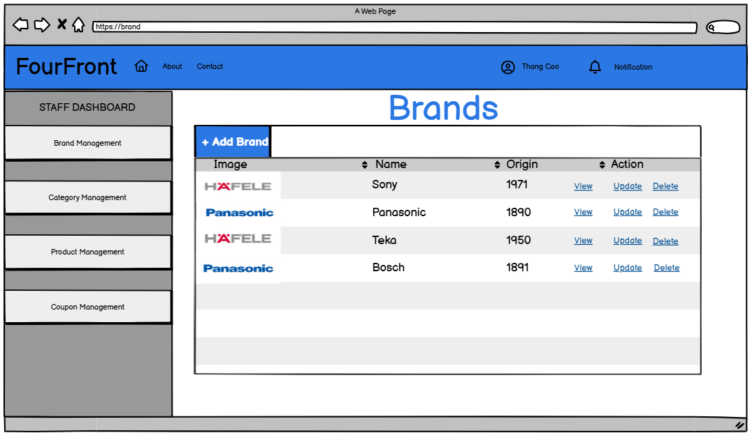

3.2.2 View Brand Detail
  - Function description:
    - Actor: Admin, Sale Staff
    - Purpose: Display detailed information about a specific brand.
    - How It’s Called:
      - Admin, Sale Staff clicks the "View" button from the Brand List Page.
      - The system retrieves and displays all relevant information about the selected brand.
    - Business rule:
      - Dashboard Sidebar: The sidebar is always visible for Admin, Sale Staff to navigate between different management sections:
        - Brand Management
        - Category Management
        - Product Management
        - Coupon Management
      - Brand Information Displayed:
        - Brand Name: Displayed prominently at the top in bold.
        - Origin: The country where the brand was founded.
        - Founded Year: The year the brand was established.
        - Description: A brief description of the brand.
      - Button:
        - Back to List Button: A button to return to the brand list.
  - Prototype:
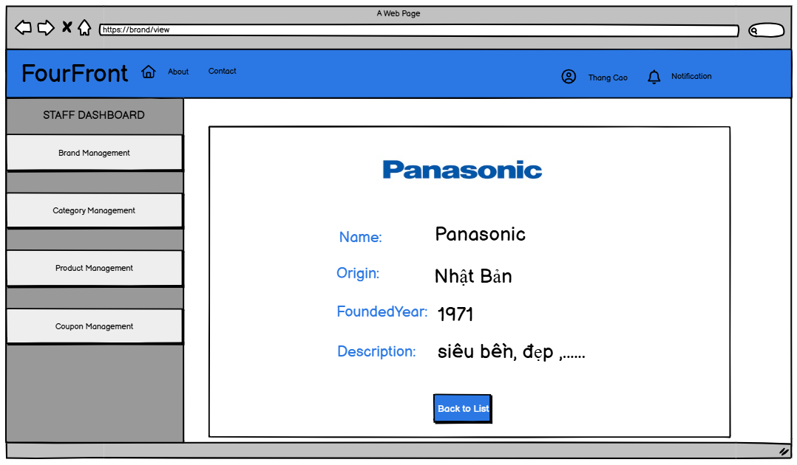

3.2.3 Update Brand Detail
Function Description
- Actor: Sale Staff, Admin
- Purpose: Allow Admin and Sale Staff to update the information of an existing brand, including name, origin, founded year, description, and image.
- How It’s Called: Admin, Sale Staff clicks the "Update" button from the Brand List Page.
Business Rules

Dashboard Sidebar: The sidebar is always visible for Admfo, Sale Staff to navigate between different management sections:
  - Brand Management
  - Category Management
  - Product Management
  - Coupon Management
- Editable Fields:
  - Name: Text input to modify the brand name.
  - Origin: Text input to update the country of the brand.
  - Founded Year: Numeric input to change the founding year.
  - Description: Text area to update the brand description.
  - Upload Image:
    - Allows Sale Staff, Admin to upload a new image file as the brand’s representative image.
    - If no image is uploaded, the current image remains unchanged.
- Buttons:
  - Update Brand: When clicked, the system updates the brand with the new information.
- Validation:
  - Name must be between 3 and 255 characters, and leading/trailing whitespace should be trimmed.
  - Origin must not be empty.
  - Founded Year must be a valid year format (e.g., 4-digit number).
  - Description should not exceed a predefined character limit (e.g., 1000 characters).
  - If any validation fails, the system will display an error message indicating the issue.
Prototype:
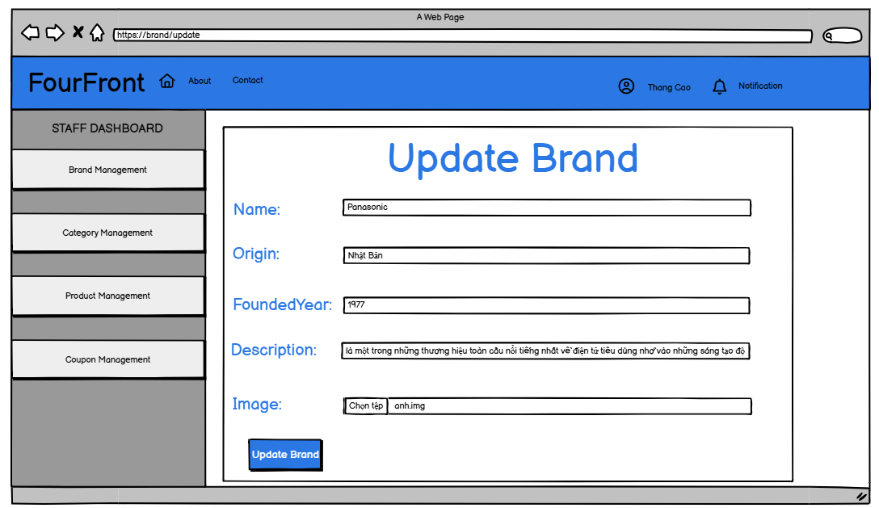

3.2.4 Add Brand
  - Function description:
    - Actor: Admin, Sale Staff
    - Purpose: Allow Admin, Sale Staff to add a new brand to the system, including name, origin, founded year, description, and image.
    - How It’s Called:
      - Admin, Sale Staff clicks the "Add Brand" button from the Brand Management page.
    - Business rule:
      - Dashboard Sidebar: The sidebar is always visible for Admin, Sale Staff to navigate between different management sections:
        - Brand Management
        - Category Management
        - Product Management
        - Coupon Management
      - Fields:
        - Name: Text input for entering the brand name.
        - Origin: Text input to specify the brand’s country of origin.
        - Founded Year: Numeric input for entering the founding year of the brand.
        - Description: Text area for providing details about the brand.
        - Image: File upload option to choose a representative image for the brand.
      - Buttons:
        - Add Brand:
          - When clicked, the system validates the input and creates a new brand with the provided details.
          - If successful, displays a confirmation message "Brand added successfully!" on the page.
      - Validation:
        - Name must be between 3 and 255 characters and should be trimmed of unnecessary whitespace.
        - Origin must not be empty.
        - Founded Year must be a valid number (e.g., 4 digits).
        - Description must not exceed the character limit (e.g., 1000 characters).
        - Image is required. If no image is uploaded, the system will display an error message prompting the user to upload an image.
        - If any validation fails, the system displays an appropriate error message.
  - Prototype:
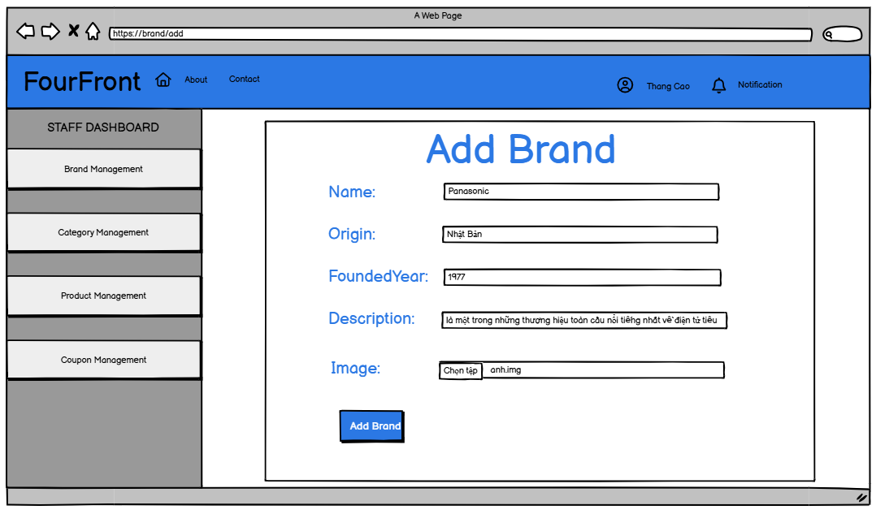

3.3 Banner

3.3.1 Manager Banner

- Function description:
  - Actor: Staff (Admin, Sale Staff)
  - Purpose: Display a list of all banners in the system. Staff can update, delete banners, and add new banners when needed.
  - How It’s Called: Staff selects the "Banner Management" option from the STAFF DASHBOARD.
  - Business rule:
    - Staff Dashboard Sidebar: The sidebar is always visible for staff members to navigate between different management sections:
      - Brand Management
      - Category Management
      - Product Management
      - Coupon Management
      - Banner Management
      - Contact Management
    - Banner Information Displayed:
      - Image: Displayed as an icon representing each banner.
      - Name: The name of the banner.
    - Buttons and Actions:
      - Update Button: Allows editing of banner information.
      - Delete Button: Allows deletion of a banner. A confirmation prompt will appear before deleting.
      - Add Banner Button: Redirects to the Add Banner page to create a new Banner.
- Prototype:
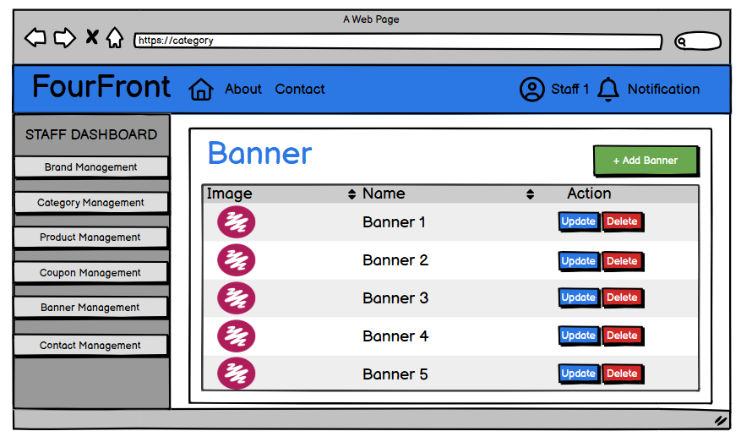

3.3.2 Add Banner

- Function description:
  - Actor: Staff (Admin, Sale Staff)
  - Purpose: Allows staff to add a new banner to the system by providing the banner’s name and image.
  - How It’s Called:
    - Staff clicks the "+ Add Banner" button from the Banner Management page
  - Business rule:
    - Staff Dashboard Sidebar: The sidebar is always visible for staff members to navigate between different management sections:
      - Brand Management
      - Category Management
      - Product Management
      - Coupon Management
      - Banner Management
      - Contact Management
    - Breadcrumb Navigation: Shows the current path (Banner/Add) to help users navigate back if needed.
    - Fields:
      - Name: Text input for entering the banner name.
      - Image: File upload option to choose a representative image for the banner.
    - Buttons:
      - Add Banner:
        - When clicked, the system attempts to create a new banner with the provided details.
        - If successful, displays a message Add successful on the page.
    - Validation:
      - All required fields (Name, Image) must be filled.
      - Name must be validated to ensure it is between 3 and 255 characters and trimmed of unnecessary whitespace.
      - If invalid, the system will display an error message indicating the issue.
      - If no image is uploaded, the system will display an message asking the user to upload an image.
- Prototype:
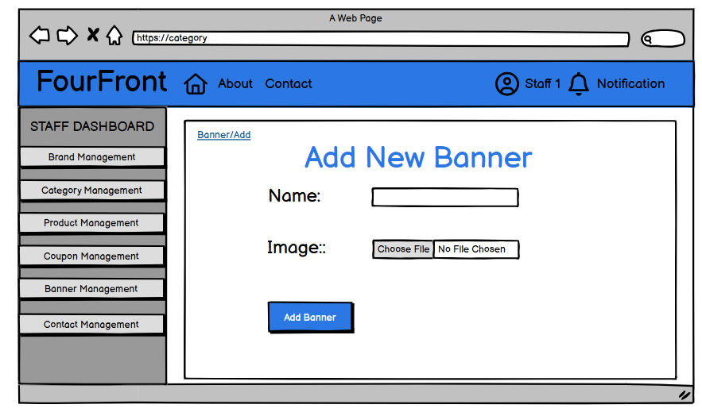

3.3.3 Update Banner
- Function description:
  - Actor: Staff (Admin, Sale Staff)
  - Purpose: Allow staff to update the information of an existing banner, including name, and image.
  - How It’s Called:
    - Staff clicks the Update button corresponding to a banner from the Banner Management page.
  - Business rule:
    - Staff Dashboard Sidebar: The sidebar is always visible for staff members to navigate between different management sections:
      - Brand Management
      - Category Management
      - Product Management
      - Coupon Management
      - Banner Management
      - Contact Management
    - Editable Fields:
      - Name: Text input to modify the banner name.
      - Upload New Image:
        - Allows staff to upload a new image file as the banner's representative image.
        - If no image is uploaded, the current image remains unchanged.
    - Breadcrumb Navigation: Shows the current path (Banner/Update) to help users easily navigate back to the list.
    - Buttons:
      - Save:
        - When clicked, the system updates the banner with the new information.
        - If successful, redirects back to the Category List Page with updated information displayed.
      - Cancel:
        - Cancels the edit operation and redirects back to the Banner List Page without making changes.
    - Validation:
      - All required fields (Name) must be filled.
      - Name must be validated to ensure it is between 3 and 255 characters and trimmed of unnecessary whitespace.
      - If invalid, the system will display an error message indicating the issue.
- Prototype:
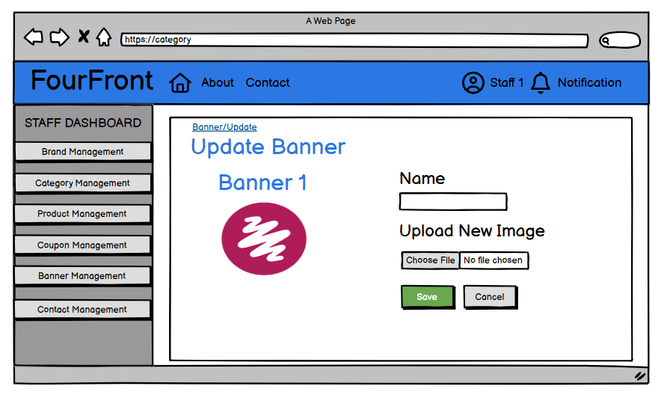

3.4 Coupon

3.4.1 View Coupon List
Function Description
- Actor: Sale Staff, Admin

Purpose:
- Show a list of coupons with details (Title, Discount, Start/Expired Date, Min Value, Quantity).

How It’s Called: Accessed via the URL /coupon
- Button & Action:
- Click on [Add Coupon] button to link URL /coupon/add to create a new coupon. Or click to dashboard
- [Filter]: Allows filtering by Title.
- [Update]: Click on "Edit Coupons" in the Action column to edit an existing coupon.
- Business Rules:
- Title must be unique.
- Discount should be between 0% - 100%.
- Start Date is a valid date.
- Expired Date must be later than or equal to the Start Date.
- Min Value(minimum order value) & Quantity must be positive numbers .
Screen Layout
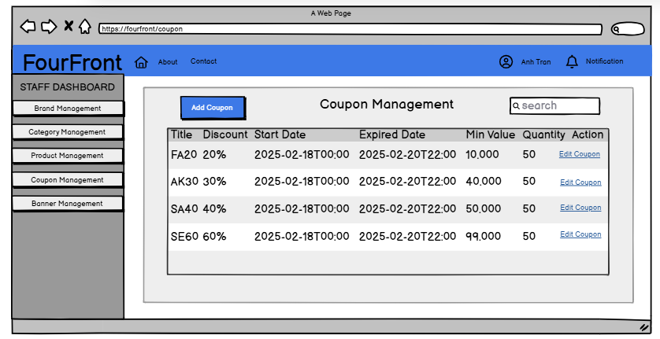

3.4.2 Create new Coupon
Function Description
- Actor: Sale Staff, Admin

Purpose:
- Allows staff to add a new coupon when all input fields are valid.

How It’s Called: Accessed via the URL /coupon/add
- Button:
- [Create Coupon] – Saves the coupon if all fields are valid.
- [Back To List] – Returns to the coupon management page..
- Business Rules:
- Title must be unique.
- Discount should be between 0% - 100%.
- Start Date is a valid date.
- Expired Date must be later than the Start Date.
- Min Value(minimum order value) & Quantity must be positive numbers.
Screen Layout
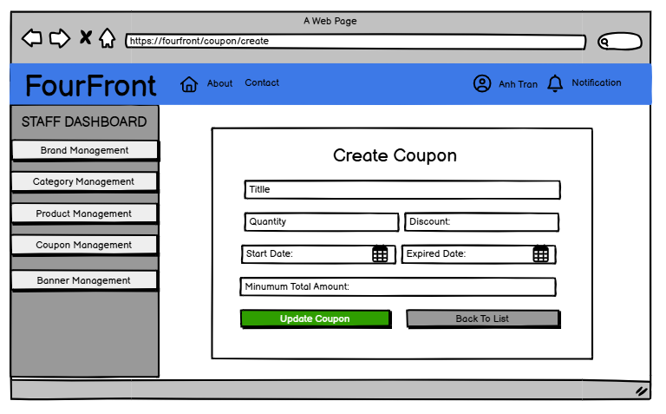

3.4.3 Update Coupon
Function Description
- Actor: Sale Staff, Admin

Purpose:
- Allows staff to view existing coupons and update coupons when all input fields are valid.

How It’s Called: Accessed via the URL /coupon/add
- Button:
- Business Rules:
- Title must be unique.
- Discount can only be viewed and cannot be updated.
- Start Date is a valid date.
- Expired Date must be later than the Start Date.
- Min Value(minimum order value) & Quantity must be positive numbers .

- Coupon Status:

Options: Active / Inactive

If set to Inactive, the staff member will be blocked from logging in.

Screen Layout
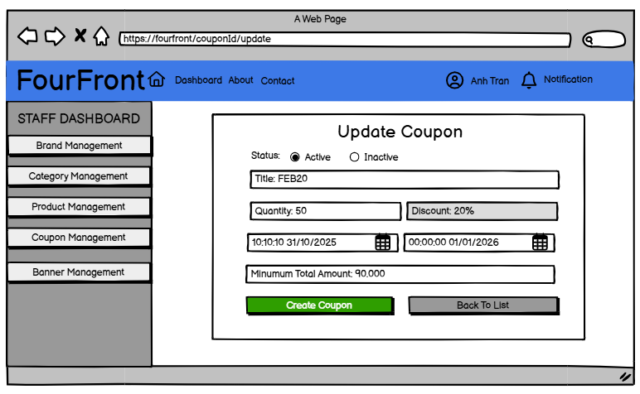

3.5 Product

3.5.1 View Product List
Function Description

Purpose:
- Show a list of products with details (Product Name, Price, Stock).

How It’s Called: Accessed via the URL /product
- Button & Action:
- [Add Product]: Click on “Add product’ button to link URL /product/add to create a new product.
- [Search]: Allows filtering by name, brand, category, price(example: 0-100, 100-200).
- [Update]: Click on "Updated" to edit an existing product.
- [Detailo]: Click on “Detail" to view the product detail.
- [Delete]: Click on “Delete" to delete the product.

Screen Layout
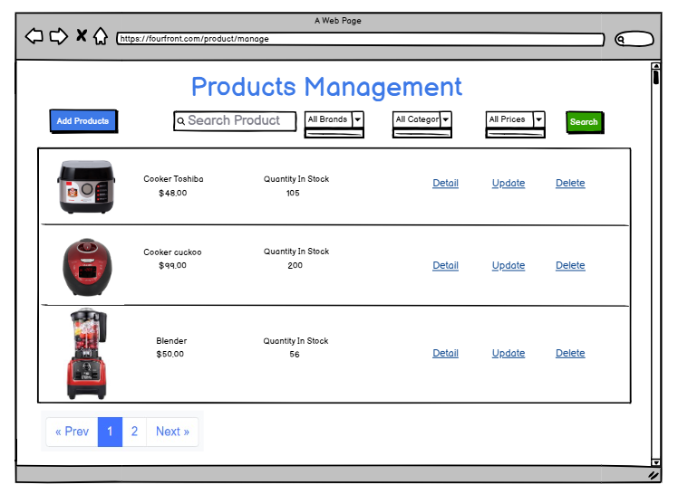

3.5.2 Create New Product
Function Description

Purpose:
- Create a new product with input field valid.

How It’s Called: Accessed via the URL /product/add
- Button & Action:
- [Add Product]: Click on “Add product’ working if input field valid.
- [Back To List] – Returns to the product management page..

- Business Rules:
- Product name: Required, cannot be empty, 3 - 255 characters.
- Price: Required, must be a positive number.
- Discount: Must be a number, value must be between 0 and 100 (if in percentage).
- Sold: Must be a number, cannot be negative.
- Stock: Must be a non-negative integer.
- Description: Required, cannot be empty. length between 10 and 2000 characters
- Product Image: Allow multiple image uploads., require at least 1 one image, max size of each image is 5MB
- Brand: Required, must be selected from the available list.
- Category: Required, must be selected from the available list.

Screen Layout

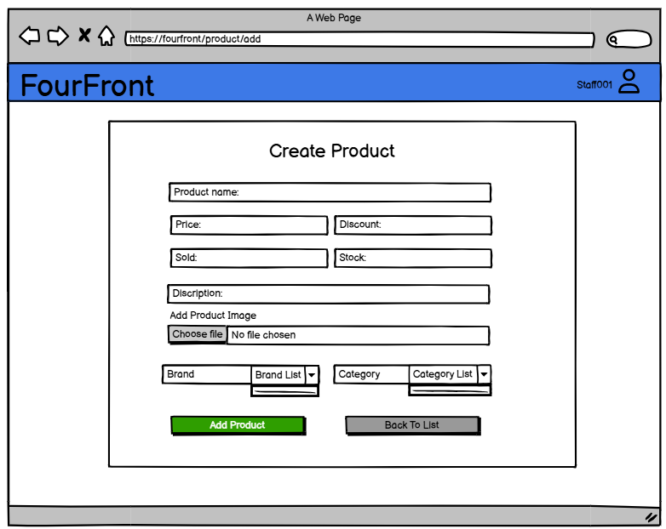

3.5.3 Update Product
Function Description

Purpose:
- Show existed product and update this.

How It’s Called: Accessed via the URL /product/id/update
- Button & Action:
- [Delete Image]: Select images using checkboxes and click "Delete Image" to remove them.
- [Update Product]: Click on “Update product’ working if input field valid.
- [Back To List] – Returns to the product management page..
- Business Rules:
- Product name: .Required, cannot be empty.
- Price: Required, must be a positive number.
- Discount: Must be a number, value must be between 0 and 100 (if in percentage).
- Stock: Must be a non-negative integer.
- Description: Required, cannot be empty.
- Product Image(Optional): Allow multiple image uploads.
- Brand: Required, must be selected from the available list.
- Category: Required, must be selected from the available list.
Screen Layout
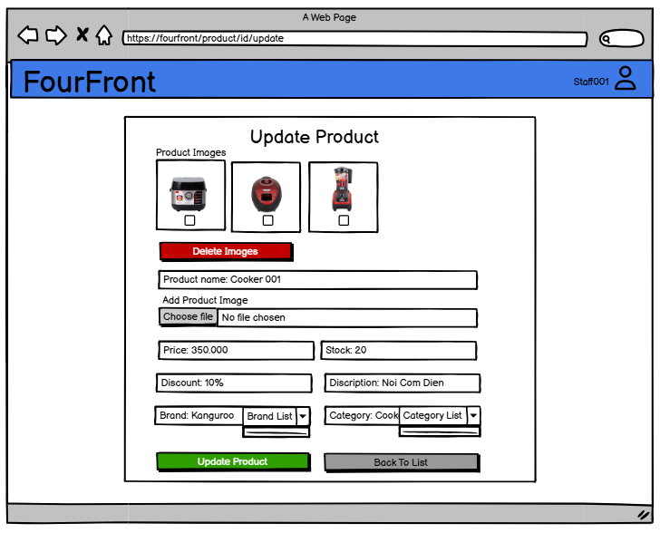

3.5.4 Product Details

Purpose: Show detail information about a product.
- How It’s Called: Accessed via the URL /product/id.
- Actors:
  - Admin/Staff: Can edit the product.
  - Guest: Must log in to add to cart.
  - Customer: Can add to cart normally.
- Features:
  - Product Details: Displays product info, price, rating.
Admin/Staff: "Edit Product" button instead of "Add to Cart".
Guest: "Login to Add to Cart" instead of "Add to Cart".
Customer: Can add to cart normally.
  - Customer Feedback: Shows only reviews for the current product.
  - Related Products: Displays items from the same category with
Admin/Staff: "Edit Product" button instead of "Add to Cart".
Guest: "Login to Add to Cart" instead of "Add to Cart".
Customer: Can add to cart normally.
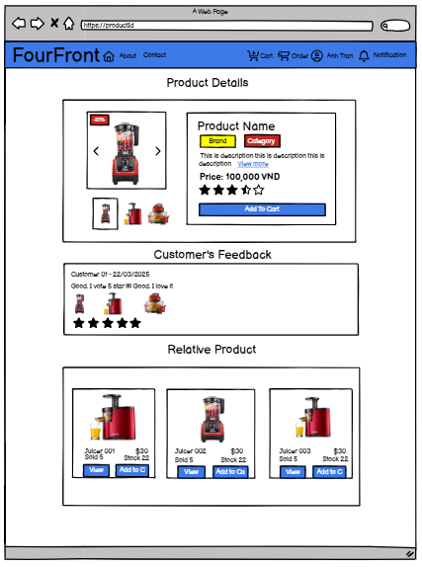

3.6 Feedback Management

3.6.1 Show list Feedback Customer

Function description:
- Actor: Sale Staff
- Purpose: Display and manage customer feedback.
- How It’s Called: /feedback/list or clicking on the "Customer Feedback" tab in the system interface.

Business rule:
- Feedback Information:
  - ▪ Customer Name: Name of the customer who provided feedback.
  - ▪ Product Name: Name of the product reviewed.
  - ▪ Rating: Star rating given by the customer.
  - ▪ Time: Timestamp of when the feedback was submitted.
- Available Actions:
  - ▪ View Feedback Details: Button labeled "View" to see full feedback details.

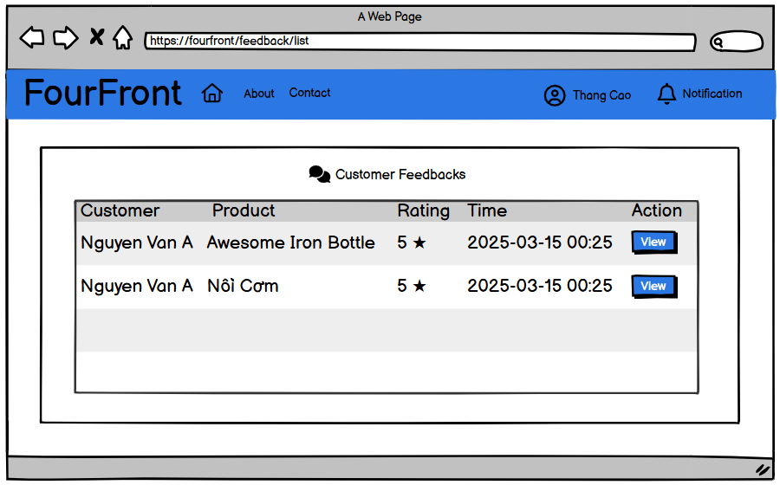

3.6.2 View Detail Feedback Customer

Function description:
- Actor: Sale Staff
- Purpose: View detailed customer feedback.
- How It’s Called: /feedback/view or clicking the "View" button in the feedback list.

Business rule:
- Feedback Details:
  - ▪ Customer ID: Unique identifier of the customer.
  - ▪ Product Name: Name of the product reviewed.
  - ▪ Rating: Star rating given by the customer.
  - ▪ Comment: Customer's written feedback.
  - ▪ Submitted On: Timestamp of when the feedback was submitted.
  - ▪ Uploaded Images: Images attached to the feedback (if any).
- Available Actions:
  - ▪ Back to List: Button labeled "Back to List" to return to the feedback list page.

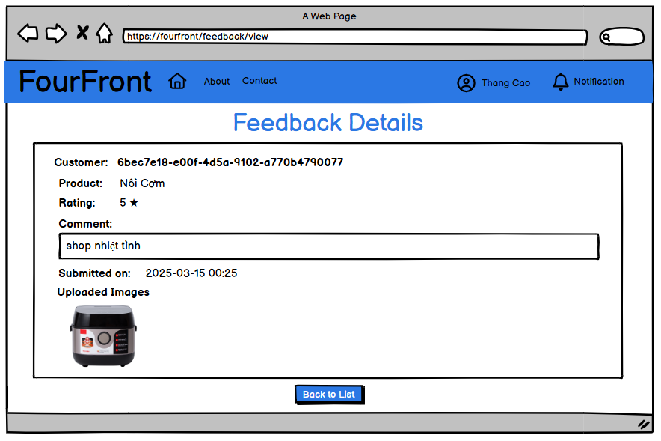

3.7 Contact

3.7.1 View Contact
  - Function description:
    - Actor: Staff (Admin, Sale Staff)
    - Purpose: Allow staff to view and manage customer contacts, including viewing, replying, and tracking reply status.
    - How It’s Called: Staff clicks the Contact Management button from the Staff Dashboard Sidebar.
    - Business rule:
      - Staff Dashboard Sidebar: The sidebar is always visible for staff members to navigate between different management sections:
        - Brand Management
        - Category Management
        - Product Management
        - Coupon Management
        - Banner Management
        - Contact Management
      - Table Display:
        - IName: The name of the user who sent the contact message.
        - Email: The email address of the user.
        - Title: The subject or title of the contact message.
        - Message: A preview of the contact message.
        - Replied: Indicates whether the message has been replied to (Replied or Pending).
        - Reply Message: Displays the reply content if available, otherwise shows Not Yet.
      - Buttons and Actions:
        - Reply Button: A button labeled Reply for each contact message.
  - Prototype:
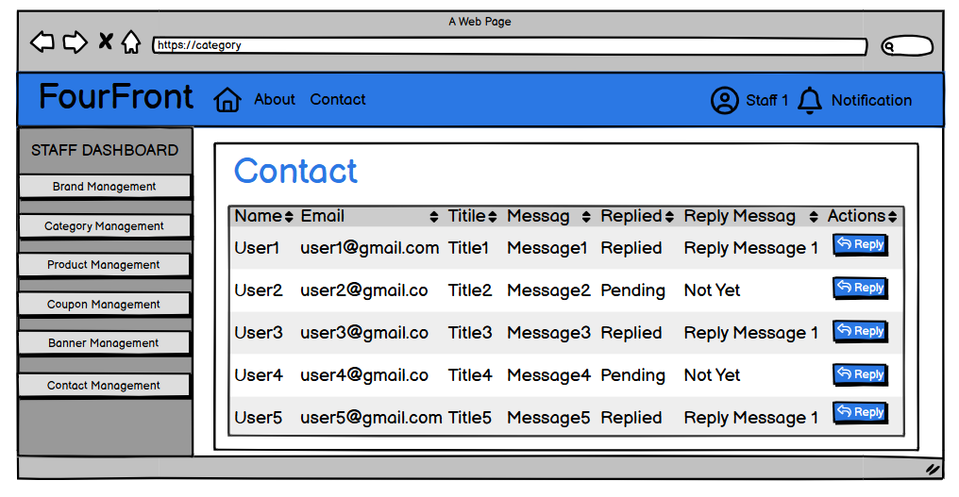

3.7.2 Reply Contact
- Function description:
  - Actor: Staff (Admin, Sale Staff)
  - Purpose: Allow staff to view and reply to a specific contact message.
  - How It’s Called: Staff clicks the Reply button from the Contact Management list.
  - Business rule:
    - Staff Dashboard Sidebar: The sidebar is always visible for staff members to navigate between different management sections:
      - Brand Management
      - Category Management
      - Product Management
      - Coupon Management
      - Banner Management
      - Contact Management
    - Breadcrumb Navigation: Shows the current path (Contact List / Reply Contact) to help users easily navigate back to the list.
    - Fields Displayed:
      - Name: (Disabled, read-only) Displayed for reference.
      - Email: (Disabled, read-only) Displayed for reference.
      - Title: (Disabled, read-only) Displayed for reference.
      - Message: (Disabled, read-only) Displays the original message sent by the user.
      - Reply Message: (Text area, required) Allows staff to enter a reply message.
    - Buttons:
      - Send Message:
        - Saves the reply message to the database.
        - Updates the contact status to “Replied”.
        - Sends an email with the reply message to the customer’s email address.
        - Redirects back to the Contact Management page.
      - Cancel:
        - Cancels the reply operation and redirects back to the Contact Management list.
  - Prototype:
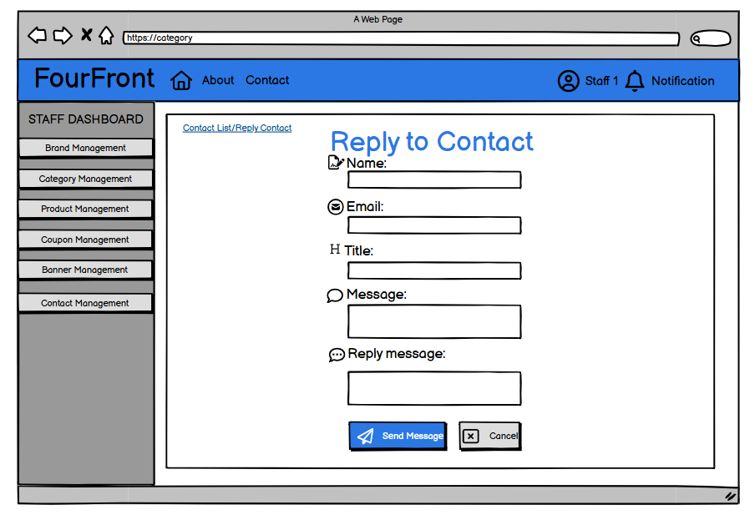

4. Admin Function

4.1 Staff Management

4.1.1 View All Staff Accounts
Function Description
- Purpose: Displays a list of staff accounts, allowing users to add, edit, and delete staff information.
- How It’s Called:
  - Accessed via the URL: /staff.
  - Triggered when the user clicks on a link or navigation button leading to the staff list from the homepage or account management menu.

Screen Layout
- Input Fields:
  - Search Bar: Allows users to enter keywords to search for staff by name, email, phone number, or position.
- Data Table Columns:
  - Customer: The name of the staff member.
  - Email: The staff member’s email address.
  - Phone: The staff member’s contact number.
  - Position: The role or job position of the staff member (e.g., SALE, DELIVERY, WAREHOUSE).
  - Action:
    - Edit (✏️): Button to edit the staff member’s details.
- Action Buttons:
  - Add Staff: Button to add a new staff member to the system.

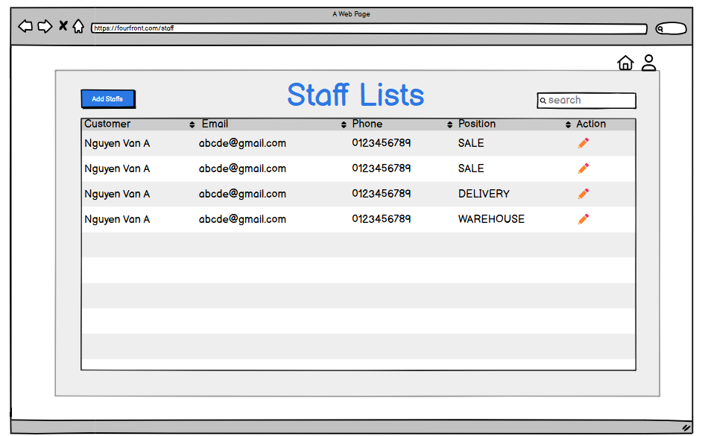

4.1.2 View Staff Information
Function Description

Purpose:
  - This feature displays detailed information about a specific staff member, allowing users to view their personal and professional details.

How It’s Called: Accessed via the URL /staff/view
Screen Layout

Fields:
  - Staff Name: The full name of the staff member.
  - Email: The staff member’s email address.
  - Gender: The gender of the staff member.
  - Phone: The staff member’s contact number.
  - Position: The staff member’s job title.
- Button:
  - Back to list Button: Returns the user to the staff list page.

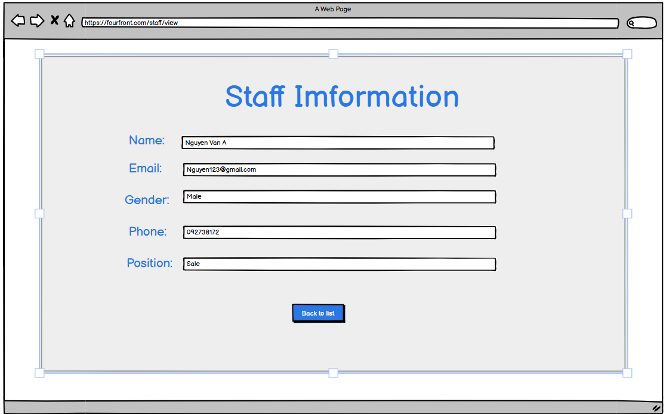

4.1.3 Create Staff Account
Function Description
- Actors: Admin

Purpose: Create account for new staff member.

How It’s Called: Accessed via the URL /staff/add
- Button:
  - The [Add Staff] button will work if all of the fields are valid.
  - The [Back To List] button redirects the admin back to the staff list page.
- Business Rule:

Username & Name Validation

The username must be unique.

First Name and Last Name must contain only letters and spaces.

Date of Birth:

Staff must be at least 18 years old.

Email Validation

Email must follow the correct format (e.g., example@gmail.com).

Password Requirements

Must be at least 8 characters long and contain letters, numbers, and special characters.

Confirm Password must match the Password field.

Salary Validation

The salary must be greater than 0.

Position Selection

Staff must select a valid position from the provided options.
Avatar Upload(Optional)
- Providing an avatar is not required.
Screen Layout
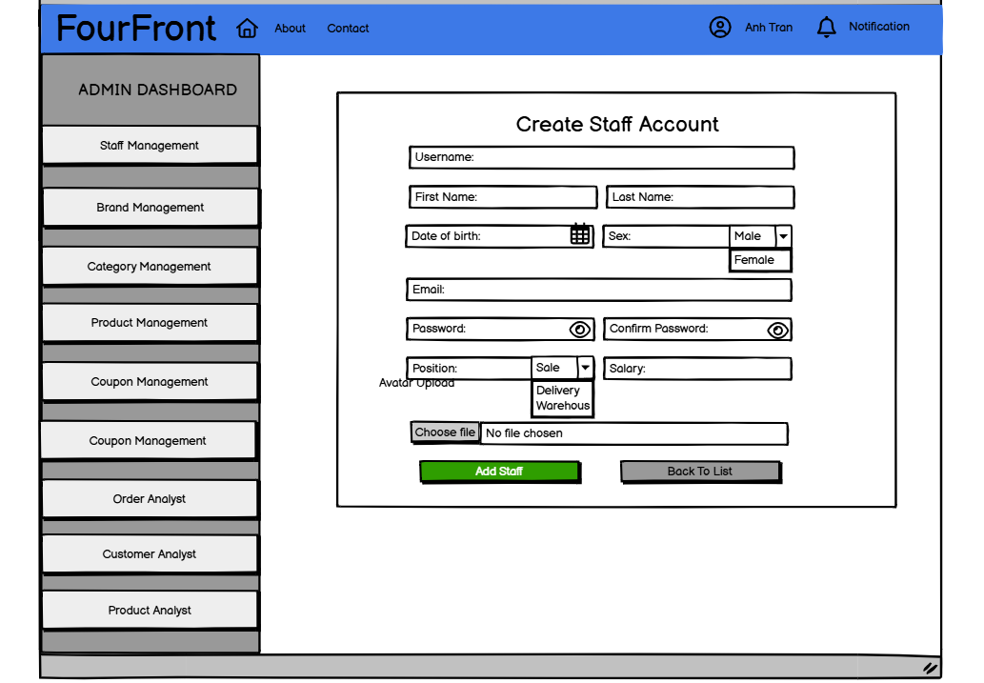

4.1.4 Update Staff Account
Function Description
- Actors: Admin

Purpose: View existed account information and update this account.

How It’s Called: Accessed via the URL /staff/id/update
- Button:
- The [Update Staff] button will work if all of the fields are valid.
- The [Back To List] button redirects the admin back to the staff list page..
- Business Rule:

Account Status:

Options: Active / Inactive

If set to Inactive, the staff member will be blocked from logging in.

Salary Validation

The salary must be greater than 0.

Position Selection

Staff must select a valid position from the provided options.
Screen Layout
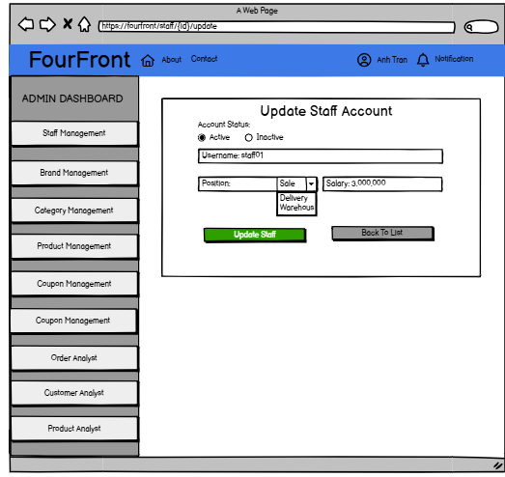

4.2 Analysis

4.2.1. Order analysis
Function description:
- Actor: Admin
- Purpose: show all orders
- How It’s Called:/order/analysis or click on order analysis on navigation bar in dashboard
- Business rule:
  - Option navigation: admin can choose analysis order by month or by year
  - Order status distribution circular chart: the chart circular chart represent percentage of status or order, each status has their own color:
    - To Pay
    - To Ship
    - To Receive
    - Completed
    - Cancelled
    - Failure
    - Feedback
    - Return/Refund
  - Time filter: the filter navigation bar to filter target time of analysis
    - Month: target month to analysis ( only available when in analysis by month option ) , it must be from 1 -> 12
    - Year: target year to analysis , it must be greater or equal to 2024, and smaller than or equal to current year
  - Filter status navigation bar: the filter navigation bar to filter target status in daily order distribution section ( or monthly order distribution ):
    - All status: count all order without consider about status
    - To Pay
    - To Ship
    - To Receive
    - Completed
    - Cancelled
    - Failure
    - Feedback
    - Return/Refund
  - Order status distribution line chart : line chart represent the count of order with specific status in each day in target month ( or each month in target year )
  - Order revenue distribution column chart: column chart represent the revenue of order in each day in target month ( or each month in target year )
Prototype:
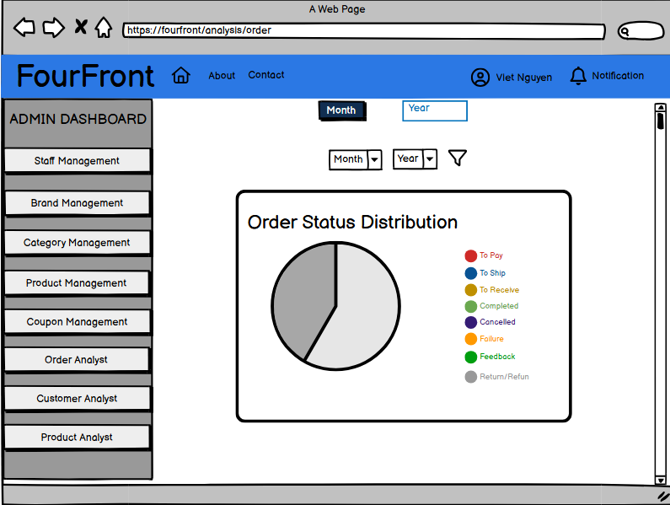
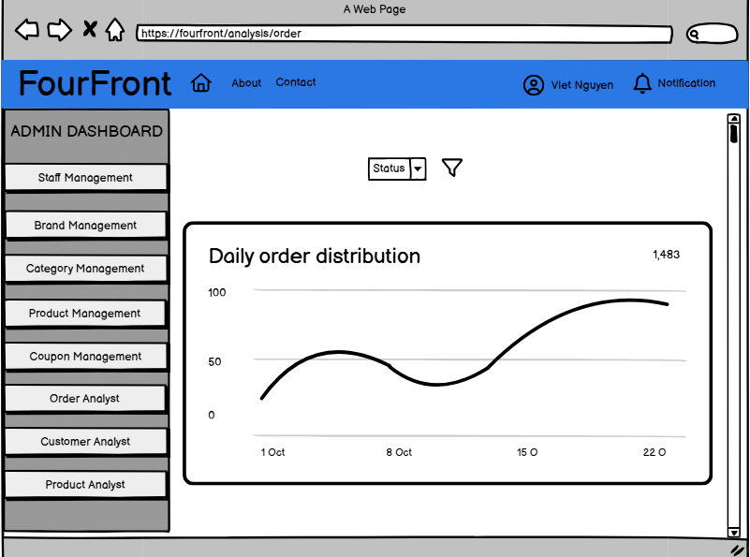
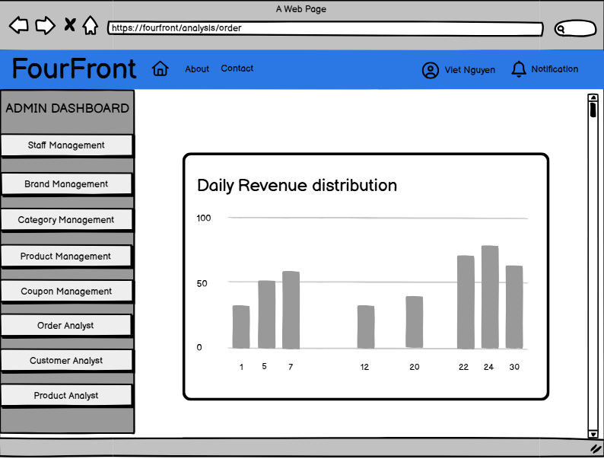

4.2.2 Product analysis
Function description:
- Actor: Admin
- Purpose: Analyze best-selling products based on completed orders.
- How It’s Called: /analysis/product or clicking "Product Analyst" in the admin dashboard.
- Business Rules:
  - Time filter: the filter navigation bar to filter target time of analysis
    - Month: target month to analysis ( only available when in analysis by month option ) , it must be from 1 -> 12
    - Year: target year to analysis , it must be greater or equal to 2024, and smaller than or equal to current year
1. Top 5 Best-Selling Products (All-Time)
- Displays the top 5 products with the highest total sold quantity across all time.
- Data includes:
  - Product image
  - Product name
  - Total units sold
  - Total completed orders
- Products are sorted in descending order based on total sold quantity.
- Helps identify the most popular products in the system.
2. Top 10 Best-Selling Products (Filtered by Time)
The admin can filter best-selling products by month and year using dropdown selections.
2.1. Monthly Best-Selling Products
- Displays the top 10 products for a selected month and year.
- Default display: Current month and year.
- Data includes:
  - Product image
  - Product name
  - Total units sold
  - Total completed orders
  - Month
  - Year
- Helps analyze short-term trends and monthly demand.
2.2. Yearly Best-Selling Products
- Displays the top 10 products for a selected year.
- Default display: Current year.
- Data includes:
  - Product image
  - Product name
  - Total units sold
  - Total completed orders
  - Year
- Helps track long-term sales performance and yearly trends.

Prototype:
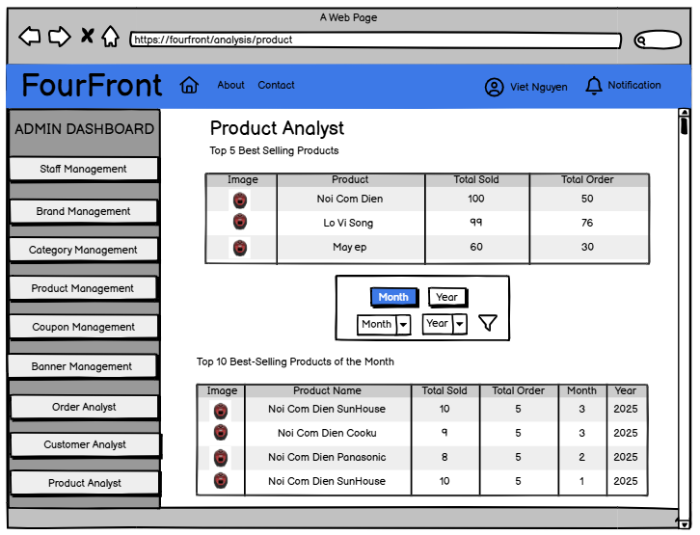
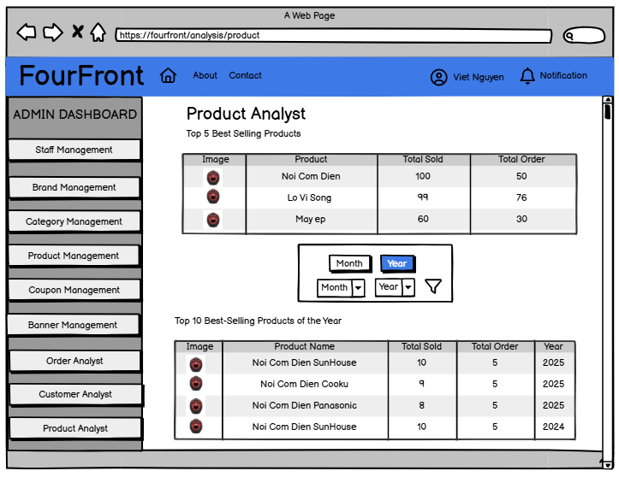

4.2.3 Customer analysis
Purpose: View top-spending customers, analyze purchase history, and access detailed customer information.
Features:
- Top 3 Customers: Displays highest total spent with a "View" button for details.
- Filter by Month/Year: Allows dynamic filtering of purchase history.
- Customer Purchase Table: Shows purchases, orders, and total spent with a "View" button.
- Customer Details (On Click "View")
Displays customer profiles
- Username
- Email
- DOB
- Sex
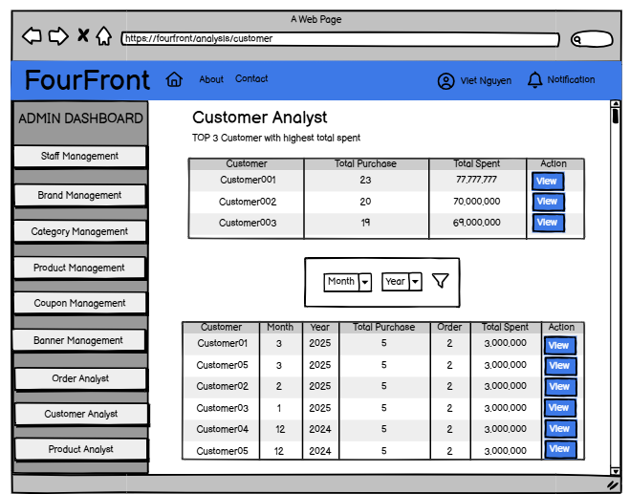

Furthermore, the Customer Analyst page provides an overview of the characteristics of customers who have completed orders.
- A pie chart displays the gender distribution of customers with "Completed" order status, helping to analyze purchasing trends by gender.
- A bar chart shows the age distribution of customers across three groups: 18-30, 30-55, and over 55, with a total percentage of 100%. This helps identify the dominant age group among purchasing customers.

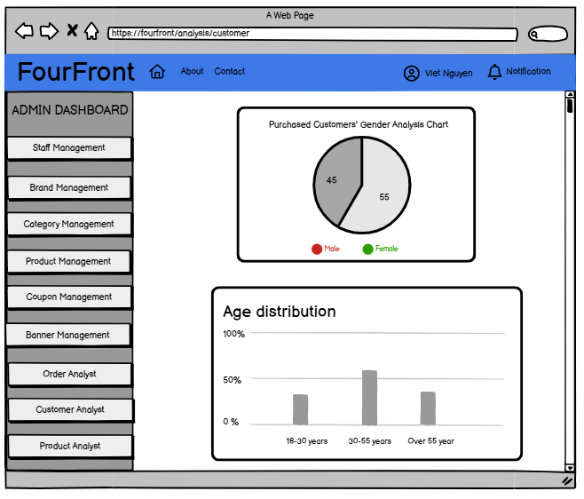

5.Delivery Staff Function

5.1 Delivery The Order

5.1.1 View All Delivery The Order

Function description:
- Actor: Delivery Staff
- Purpose: Display all user orders for delivery management.
- How It’s Called: /order/delivery or clicking on the "To Receive" tab in the order interface.

Business rule:
- Order Category Options: Users can filter orders based on their current status:
  - ▪ To Receive (Waiting for delivery)
  - ▪ Completed (Successfully delivered)
  - ▪ Return/Refund (Return or refund request)
- Order Information:
  - ▪ Order ID: Unique identifier for each order.
  - ▪ Product Image
  - ▪ Product Name
  - ▪ Product Price
  - ▪ Product Quantity
  - ▪ Total Amount: Includes shipping fees.
  - ▪ Shipper Name
- Filtering Options:
  - ▪ Filter Orders by Status
- Available Actions:
  - ▪ View Order Details: Button labeled "View" to see full order details.
  - ▪ Mark Order as Completed: Button labeled "Completed" to confirm successful delivery.
  - ▪ Request Return or Refund: Button labeled "Return/Refund" to initiate a return or refund process.
Screen Layout

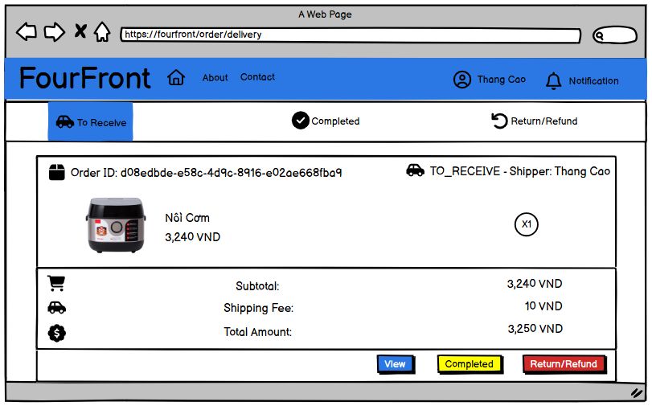

5.1.2 View Detail Delivery The Order

Function Description:
- Actor: Delivery Staff
- Purpose: Displays order details, including customer information, shipping address, and the list of items in the order.

How It’s Called:
- Access via URL: /order/view
- Or click on a specific order from the order list.

Business Rules:

Order Information Section:
- Order ID: Displays the unique order identifier.
- Customer Name: Name of the customer who placed the order.
- Current Status: Order status (e.g., TO_RECEIVE, COMPLETED, CANCELED, etc.).
- Created At: Date and time the order was created.

Shipping Addresses Section:
- Receiver Name: Name of the recipient.
- Phone Number: Contact number of the recipient.
- House Number: The house number of the recipient.
- Commune, District, City: Full shipping address details.

Order Items Section:
- Item Name: Name of the product in the order.
- Quantity: Number of items ordered.
- Price: Price of each product in the order.

Navigation & Actions:
- Back To Orders: A button to navigate back to the order list.
Screen Layout

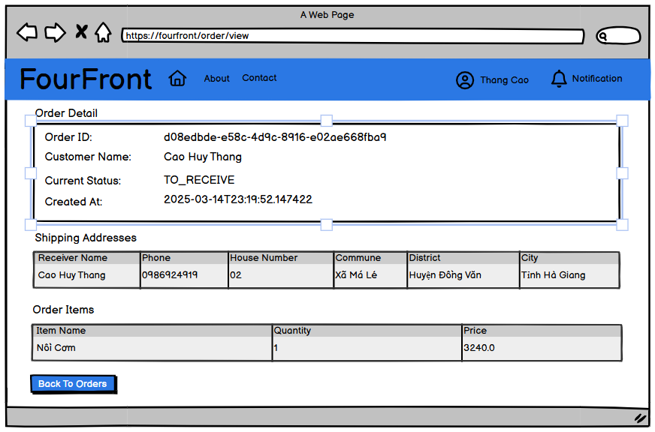

6.Warehouse Staff Function
- Actors:
  - Admin/Staff: Can manage orders.
- Purpose:
Allows Admin/Staff to view and manage orders based on their status.
- Features & Business Rules:
  - View Orders by Status:
- Orders are categorized into To Ship, To Receive, Complete, Return/Refund.
- Default view: To Ship orders.
- Order Actions:(if order status is To_Ship)
  - Assign: Approve and process shipping.
  - Reject: Decline the order. When clicking on, a popup modal appears with a warning message
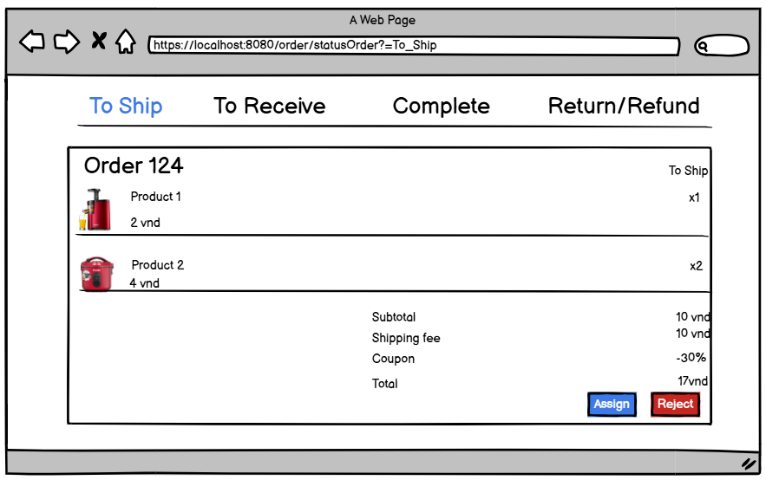
- If order status is To_Receive and show delivery staff of this order.
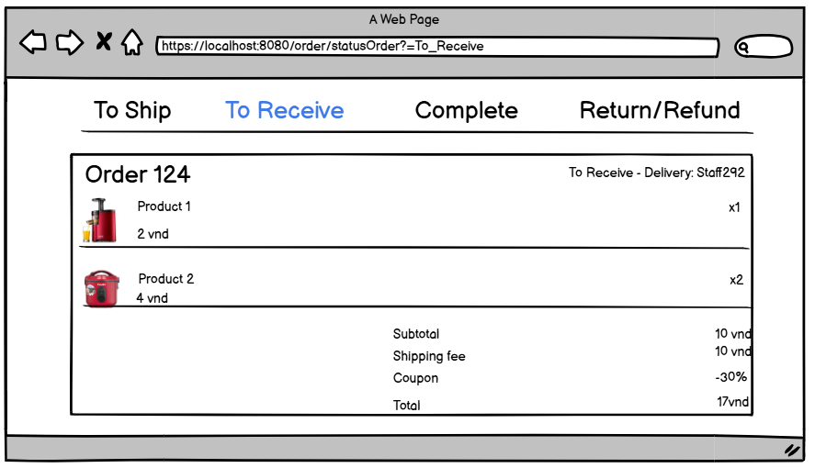

III. System Design

1. Database Design

1.1 Database Schema

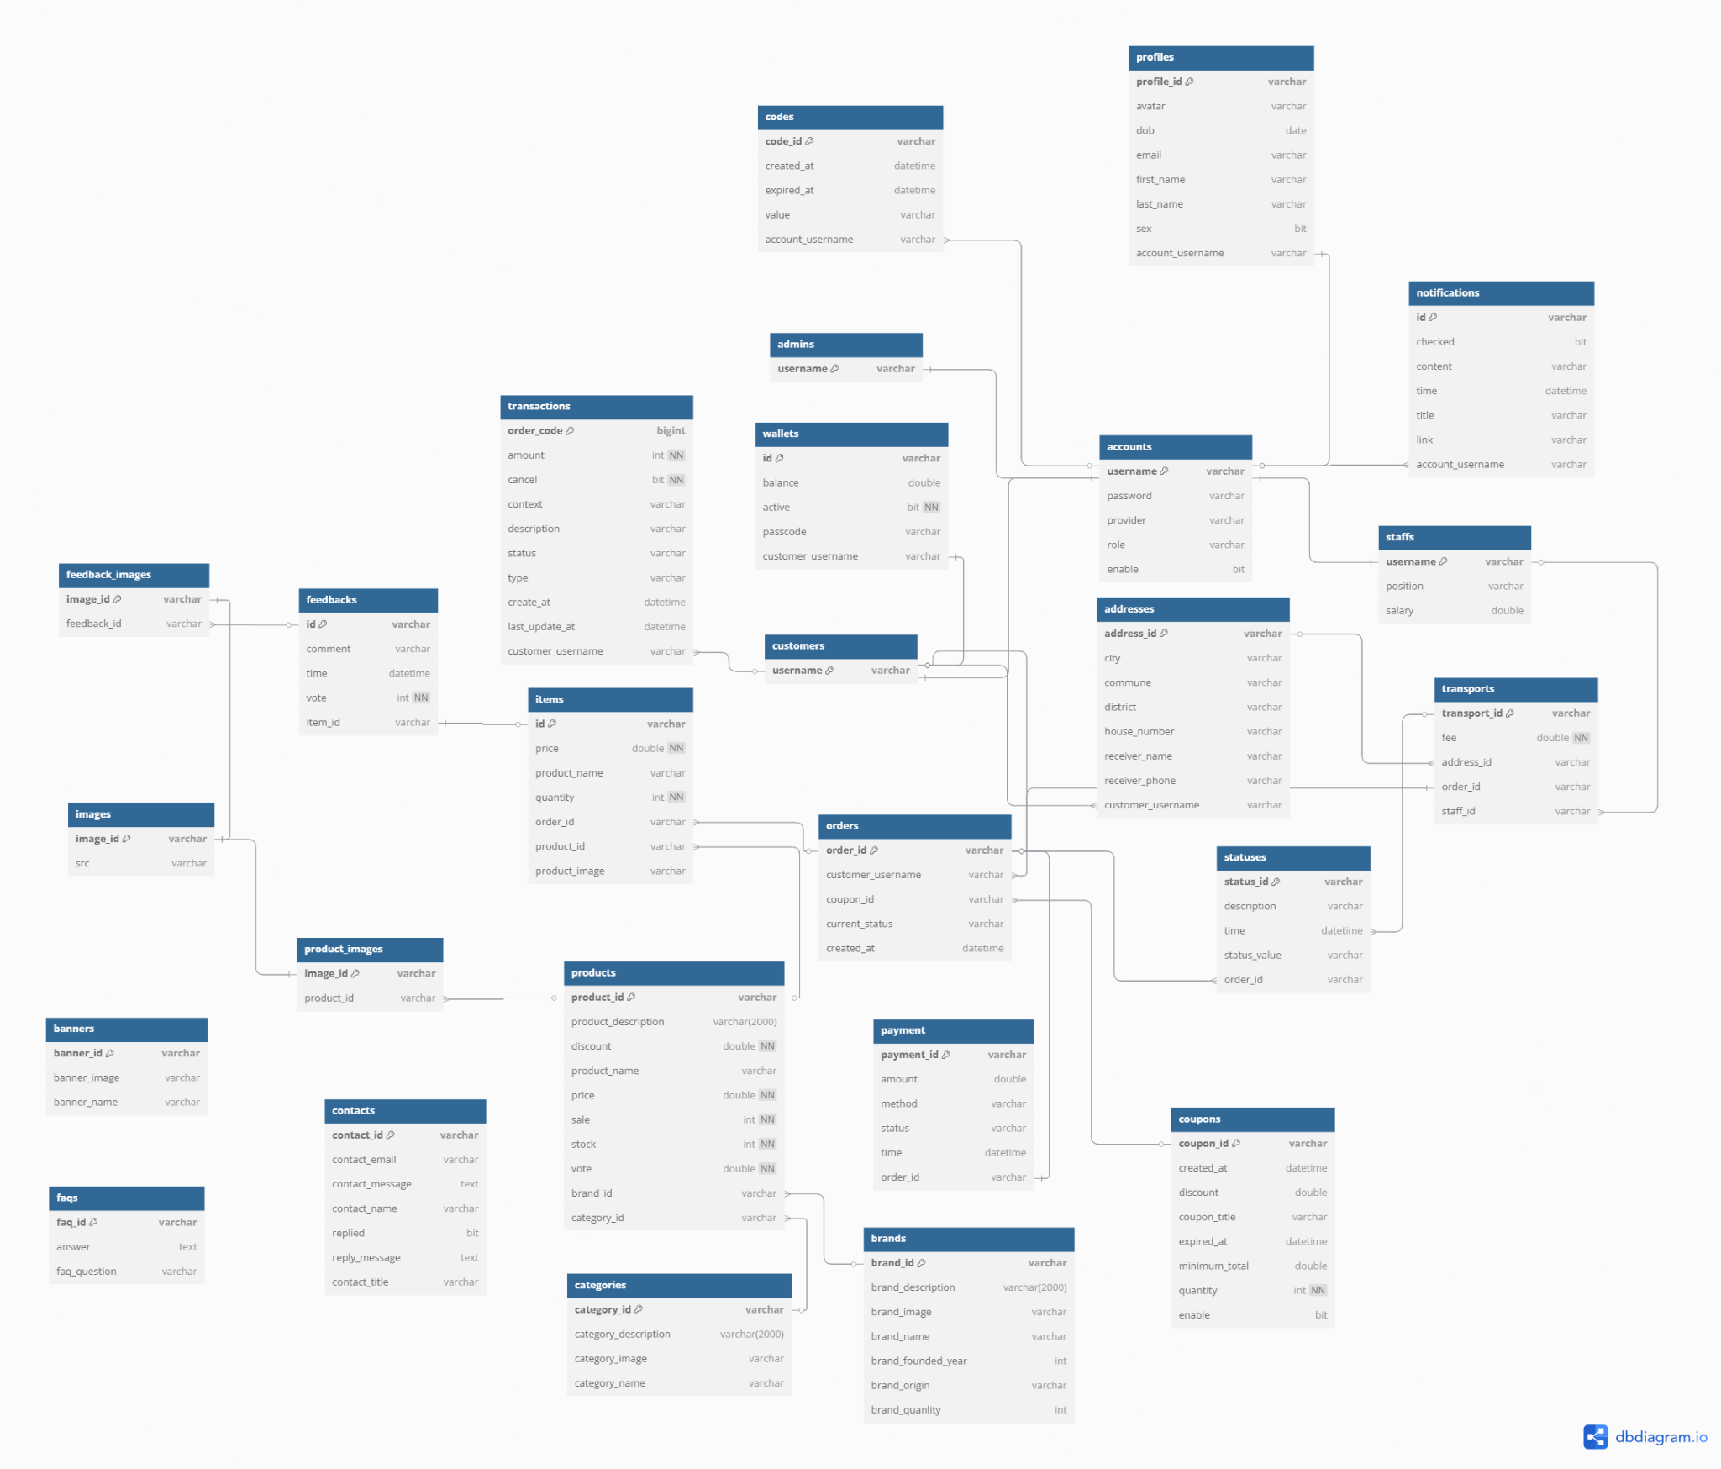

1.2 Table Descriptions
No | Table | Description
01 | Codes | Description: Tracks unique codes.  - Primary keys: code_id  - Foreign keys: account_username  - Unique keys: code_id
02 | Profiles | Description: Contains user profile details.  - Primary keys: profile_id  - Foreign keys: account_username  - Unique keys:profile_id
03 | Notifications | Description: Manages notifications sent to user profiles.  - Primary keys: code_id  - Foreign keys: account_username  - Unique keys: code_id
04 | Accounts | Description: Stores user account details.  - Primary keys: username  - Foreign keys: none  - Unique keys: username
05 | Staffs | Description: Stores information of staff.  - Primary keys: username  - Foreign keys: account_username  - Unique keys: username
06 | Customers | Description: Stores username of customer.  - Primary keys: username  - Foreign keys: username  - Unique keys: username
07 | Transports | Description: Manages information on shipping for orders.  - Primary keys: transport_id  - Foreign keys: staff_id, address_id, order_id  - Unique keys: transport_id
08 | Addresses | Description: Stores information on the address for the user.  - Primary keys: address_id  - Foreign keys: customer_username  - Unique keys: address_id
09 | Coupons | Description: Stores information on coupon.  - Primary keys: coupon_id  - Foreign keys: none  - Unique keys: coupon_id
10 | Feedbacks | Description: Stores information on feedback of customers.  - Primary keys: feedback_id  - Foreign keys: item_id  - Unique keys: feedback_id
11 | FeedbackImages | Description: Stores image of feedback.  - Primary keys: image_id  - Foreign keys: feedback_id  - Unique keys: image_id
12 | Orders | Description: Stores information of order.  - Primary keys: order_id  - Foreign keys: customer_username, coupon_id  - Unique keys: order_id
13 | Status | Description: Stores status of order.  - Primary keys: status_id  - Foreign keys: none  - Unique keys: status_id
14 | Payment | Description: Stores information of payment method.  - Primary keys: payment_id  - Foreign keys: orderId  - Unique keys: payment_id
15 | Items | Description: Stores information of items  - Primary keys: item_id  - Foreign keys: order_id, product_id, product_name  - Unique keys: item_id
16 | Categories | Description: Stores information of category.  - Primary keys: category_id  - Foreign keys: None  - Unique keys: category_id
17 | Products | Description: Stores information of the product.  - Primary keys: product_id  - Foreign keys: category_id, brand_id  - Unique keys: product_id
18 | ProductImages | Description: Stores images of product.  - Primary keys: image_id  - Foreign keys: product_id  - Unique keys: image_id
19 | Brands | Description: Stores information of brand.  - Primary keys: brand_id  - Foreign keys: None  - Unique keys: brand-id
20 | Images | Description: Stores all images including feedback, product.  - Primary keys: image_id  - Foreign keys: image_id  - Unique keys: image_id
21 | Transactions | Description: Stores all transaction of customer  -Primary keys: order_code  -Foreign keys: customer_username  -Unique keys: order_code
22 | Banners | Description: Stores all banner of homepage  - Primary keys: banner_id  - Foreign keys: none  - Unique keys: banner_id
23 | Wallets | Description: Stores customer wallet details.  - Primary keys: id  - Foreign keys: customer_username  - Unique keys: id
24 | Contact | Description: Stores contact from guest  - Primary keys: id  - Unique keys: id
25 | faqs | Description: Stores questions faq  - Primary keys: id  - Unique keys: id

2. Code Packages

2.1 Packages Diagram

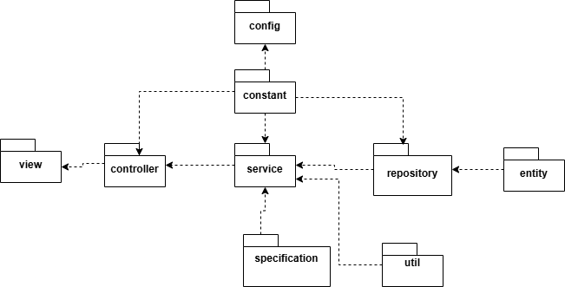

2.2 Package Descriptions
No | Package | Description
01 | config | Contains configuration files for the application (e.g., CORS, security, database, logging).
02 | constant | Stores constant values used throughout the application.
03 | controller | Handles incoming client requests (API endpoints).
04 | entity | Represents database tables (mapped using ORM like Hibernate).
05 | repository | Manages database queries, typically using JpaRepository
06 | service | Contains business logic, processing data before interacting with repositories or controllers.
07 | specification | Defines custom search criteria
08 | util | Includes utility/helper functions
09 | view | Includes html, css, js for view

